CHAPTER 10
HYPOTHESIS TESTS INVOLVING
A SAMPLE MEAN OR PROPORTION

SECTION EXERCISES
10.1 d/p/m The null hypothesis is a statement about the value of a population parameter. It is assumed to be true unless we have evidence to the contrary. The alternative hypothesis is an assertion that holds if the null hypothesis is false. The null hypothesis is not always the same as the verbal claim or assertion that led to the test. The null hypothesis must always contain the equal sign. If the directional claim does not contain an equal sign, then the claim is put in the alternative hypothesis and the opposite is put in the null hypothesis.

10.2 d/p/m
a . Appropriate
b. Appropriate
c. Inappropriate. The equal sign must be in the null hypothesis.
d. Inappropriate. Both hypotheses contain the same signs, the value differs for H₀ and H₁
and the alternative hypothesis contains an equal sign.
e. Inappropriate. A hypothesis is a statement about a population parameter, not a sample
statistic.
f. Inappropriate. A hypothesis is a statement about a population parameter, not a sample
statistic.

10.3 d/p/m
a. Inappropriate. The value given is different in the two hypotheses.
b. Appropriate
c. Appropriate.
d. Inappropriate. The null and alternative hypotheses do not include all possible values of
the population parameter.
e. Appropriate.
f. Inappropriate. A hypothesis is a statement about a population parameter, not a sample
statistic like p.

10.4 d/p/m The test would be one-tail and the appropriate null and alternative hypotheses
would be H₀: π ≥ 0.85 and H₁: π < 0.85.

10.5 d/p/m If the scientist’s null hypothesis that “global warming is taking place” is correct, but people do not take her seriously, they would be making a Type I error by rejecting a true null hypotheis.

10.6 d/p/m H₀: The person is telling the truth; H₁: The person is not telling the truth
A Type I error would be committed if we decided the person is not telling the truth when he was telling the truth.
A Type II error would be committed if we decided the person is telling the truth when he was not telling the truth.

10.7 d/p/m The engineer would least like to commit a Type II error since a lot of people could be killed if this occurred. A Type II error would be committed if he decided that the stadium was structurally sound when it was not.

10.8 d/p/m Let π = population proportion of cars that are reported stolen when they were not. Since this is a nondirectional claim, we will use a two-tail test. H₀: π = 0.10; H₁: π ≠ 0.10

10.9 d/p/m Since this is a directional claim, we will use a one-tail test. H₀: π ≤ 0.10; H₁: π > 0.10

10.10 d/p/m
a. H₀: μ ≤ 300; H₁: μ > 300 One-tail test b. H₀: μ = 1.5; H₁: μ ≠ 1.5 Two-tail test.
c. H₀: μ ≥ 1200; H₁: μ < 1200 One-tail test d. H₀: μ = 3.5; H₁: μ ≠ 3.5 Two-tail test.

10.11 d/p/m H₀: Person is not drunk; H₁: Person is drunk
A Type I error would be committed if the officer decides the person is drunk since he can't walk a straight line or close his eyes and touch his nose, when he really was not drunk. This could occur if a person is tired, frightened, or has a physical disability.
A Type II error would be committed if the officer decides the person is not drunk since he can walk a straight line or close his eyes and touch his nose, but he really is drunk. This could occur because a person drinks quite often and therefore can withstand more.

10.12 d/p/m
a. In order to NEVER make a Type I error, you would have to always fail to reject H₀, since a Type I error cannot be made unless you reject H₀. Therefore, the judge has instructed the jury not to decide the defendant is guilty.
b. In order to NEVER make a Type II error, you would have to reject H₀ since a Type II error can not be made unless you fail to reject H₀, Therefore, the judge has instructed the jury not to decide the defendant is innocent.
c. The jury would try to make the best decision they could from the evidence given. However, they need to remember that they might make a Type I or a Type II error. They would try to minimize the chances of these errors occurring.

10.13 d/p/m She appears to favor Type I error. In this case, Type I error would be deciding that a drug is harmful when it really isn't.

10.14 d/p/m We should use a t-test to carry out the analysis since σ is unknown but we are reasonably sure the population is approximately normally distributed.

10.15 d/p/m Let π = population proportion of women aged 40 - 49 in NYC who save in a 401(k) or individual retirement account. H₀: π = 0.62 H₁: π ≠ 0.62
This test would be a z-test since nπ = 300(0.62) = 186 and n(1-π) = 300(1 - 0.62) = 114 are ≥ 5.

10.16 d/p/m The decision rule specifies the conclusion to be reached for a given outcome of the test
(e.g., Reject H₀ if the calculated z > 1.96). The decision rule helps us to decide whether to reject H₀
or fail to reject H₀ for a hypothesis test.

10.17 d/p/m The larger the value of α, the greater the likelihood of committing a Type I error.
For this exercise, a Type I error would be deciding the mean tensile strength of the rivets is below 3000 pounds when it is really 3000 pounds or above. With the null and alternative hypotheses,
H₀: μ ≥ 3000; H₁: μ < 3000 :
a. The marketing director for a major competitor would prefer a numerically high level of significance (e.g., α = 0.20) to be used in reaching a conclusion. This would make it easier to conclude that the mean tensile strength is below 3000 pounds when it really is 3000 or above.
b. The rivet manufacturer's advertising agency would prefer a numerically low level of significance
(e.g., α = 0.01) to be used in reaching a conclusion. This would make it more difficult to conclude that the mean tensile strength is below 3000 pounds when it really is 3000 or above. They have already claimed the mean tensile strength to be at least 3000 pounds, so they don’t want a test result to suggest otherwise.

10.18 d/p/m Let π = population proportion of defective units. H₀: π ≤ 0.05 H₁: π > 0.05
This is a one-tail test since this is a directional claim ("no more than 5%"). It is a right-tail test since the alternative hypothesis has a greater-than sign. The rejection region is located in the right tail of the standard normal curve.

10.19 d/p/m If the sample size is large (n ≥ 30), the central limit theorem assures us that the distribution of sample means will be approximately normally distributed regardless of the shape of the underlying population. The larger the sample size, the better this approximation becomes. When the central limit theorem applies, we may use the standard normal distribution to identify the critical values for the test statistic when σ is known.

10.20 d/p/e If n < 30, we must assume that the underlying population is normally distributed in order to use the z-statistic.

10.21 d/p/m A p-value is the exact level of significance associated with the calculated value of the test statistic. It is the most extreme critical value that the test statistic would be capable of exceeding.
If p-value < α, reject H₀ and if p-value ≥ α, do not reject H₀.

10.22 d/p/m Since p-value = 0.03 is less than α = 0.05, the null hypothesis would be rejected. The sample result is more extreme than you would have been willing to attribute to chance.

10.23 d/p/m Since p-value = 0.04 is not less than α = 0.01, the null hypothesis would be not be rejected. The sample result is not more extreme than you would have been willing to attribute to chance.

10.24 d/p/m If we are unable to reject H₀, then the p-value is not less than the level of significance being used (α = 0.01), or p-value ≥ 0.01.

10.25 c/a/m Using the standard normal table,
a. p-value = P(z ≥1.54) = 1.0000 - 0.9382 = 0.0618
b. p-value = P(z ≤ -1.03) = 0.1515
c. p-value = 2P(z ≤ -1.83) = 2(0.0336) = 0.0672

10.26 c/a/m Using the standard normal table,
a. p-value = P(z ≤ -1.62) = 0.0526
b. p-value = P(z ≥1.43) = 1.0000 - 0.9236 = 0.0764
c. p-value = 2P(z ≥ 1.27) = 2(1.0000 – 0.8980) = 2(0.1020) = 0.2040
10.27 c/a/m Null and alternative hypotheses:
H₀: μ = 450 H₁: μ ≠ 450 Level of significance: α = 0.05
Test results: = 458, n = 35 (known: σ = 20.5)
Calculated value of test statistic: 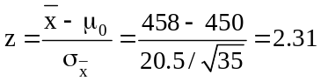
Critical values: z = -1.96 and z = 1.96 (in the normal distribution, the area between z = -1.96 and
z = 1.96 is 0.95, and the sum of the two tail areas is 0.05).
Decision rule: Reject H₀ if the calculated z < -1.96 or > 1.96, otherwise do not reject.
Conclusion: Since calculated test statistic falls in rejection region (z = 2.31 > 1.96), reject H₀.
Decision: At the 0.05 level, the results suggest that the population mean is not 450.
Using the standard normal distribution table, we can find the approximate p-value as twice the area to the right of z = 2.31. This is 2(1.0000 - 0.9896) = 2(0.0104) = 0.0208.

Given the summary data, we can also carry out this z-test using the Test Statistics workbook that accompanies Data Analysis Plus. The results are shown below. For this two-tail test, the p-value (0.0210) is less than the 0.05 level of significance being used to reach a conclusion, so the null hypothesis is rejected. For a true null hypothesis, there is only a 0.0210 probability that a sample mean this far away from 450 would occur by chance.
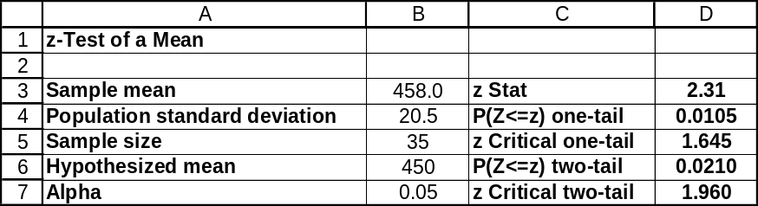

10.28 c/a/m Null and alternative hypotheses:
H₀: μ ≤ 220 H₁: μ > 220 Level of significance: α = 0.05
Test results: = 230.8, n = 12 (known: σ = 17 and the population is normally distributed.)
Calculated value of test statistic: 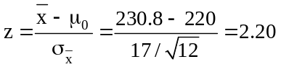
Critical value: z = 1.645 (in the normal distribution, the area to the right of z = 1.645 is 0.05).
Decision rule: Reject H₀ if the calculated z > 1.645, otherwise do not reject.
Conclusion: Since calculated test statistic falls in rejection region (z = 2.20 > 1.645), reject H₀.
Decision: At the 0.05 level, the results suggest that the population mean is greater than 220.
Using the standard normal distribution table, we can find the approximate p-value as the area to the right of z = 2.20. This is 1.0000 - 0.9861 = 0.0139.

Given the summary data, we can also carry out this z-test using the Test Statistics workbook that accompanies Data Analysis Plus. The results are shown below. For this right-tail test, the p-value (0.0139) is less than the 0.05 level of significance being used to reach a conclusion, so the null hypothesis is rejected. For a true null hypothesis, there is only a 0.0139 probability that a sample mean this much larger than 220 would occur by chance.

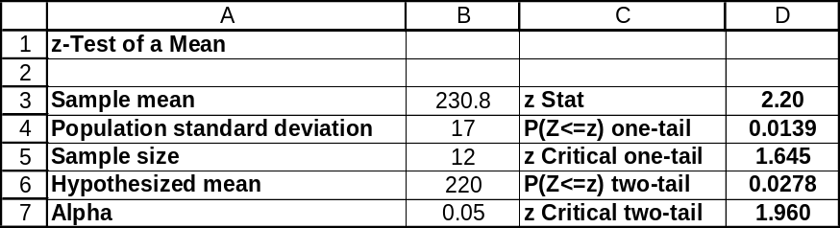

10.29 p/a/m Null and alternative hypotheses:
H₀: μ = 2 (machine in adjustment) H₁: μ ≠ 2 (machine out of adjustment)
Level of significance: α = 0.01
Test results: = 2.025, n = 35 (known: σ = 0.07)
Calculated value of test statistic: 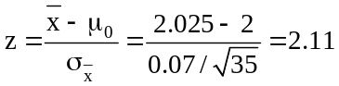
Critical values: z = -2.58 and z = 2.58 (in the normal distribution, the area between z = -2.58
and z = 2.58 is 0.99, and the sum of the two tail areas is 0.01).
Decision rule: Reject H₀ if the calculated z < -2.58 or > 2.58, otherwise do not reject.
Conclusion: Since calculated test statistic falls in nonrejection region (-2.58 < z = 2.11 < 2.58) do not
reject H₀.
Decision: At the 0.01 level, results suggest the machine is properly adjusted. It appears the mean length of nails produced by the machine could be 2 inches. The difference between the hypothesized population mean and the sample mean is judged to have been merely the result of chance variation.
Using the standard normal distribution table, we can find the approximate p-value as twice the area to the right of z = 2.11. This is 2(1.0000 - 0.9826) = 2(0.0174) = 0.0348.

Given the summary data, we can also carry out this z-test using the Test Statistics workbook that accompanies Data Analysis Plus. For this two-tail test, the p-value (0.0346) is not less than the 0.01 level of significance being used to reach a conclusion, so the null hypothesis is not rejected. For a true null hypothesis, there is a 0.0346 probability that a sample mean this far away from 2.000 inches would occur by chance.
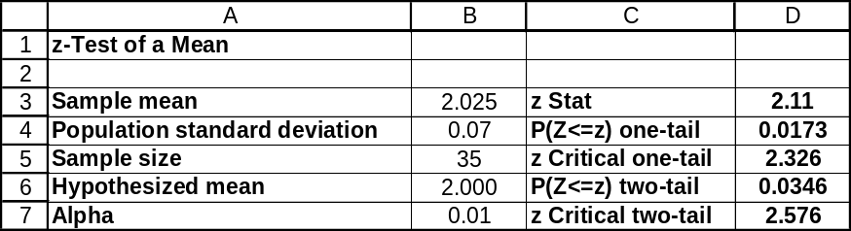

10.30 p/a/m Null and alternative hypotheses:
H₀: μ ≥ 5.00 (no decline in spending) H₁: μ < 5.00 (a decline)
Level of significance: α = 0.05
Test results: = 4.20, n = 18 (known: σ = 1.80 and the population is normally distributed.)
Calculated value of test statistic: 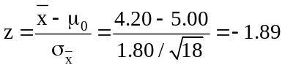
Critical value: z = -1.645 (in the normal distribution the area to the left of z = -1.645 is 0.05).
Decision rule: Reject H₀ if the calculated z < -1.645, otherwise do not reject.

Conclusion: Calculated test statistic falls in rejection region, reject H₀.
Decision: At the 0.05 level, the results suggest a decline in spending on popcorn and snacks at the cinema complex. It appears the average amount spent is now less than $5.00.
Using the standard normal distribution table, we can find the approximate p-value as the area to the left of z = -1.89. This is 0.0294.

Given the summary data, we can also carry out this z-test using the Test Statistics workbook that accompanies Data Analysis Plus. For this left-tail test, the p-value (0.0297) is less than the 0.05 level of significance being used to reach a conclusion, so the null hypothesis is rejected. For a true null hypothesis, there is only a 0.0297 probability that a sample mean this much less than $5.00 would occur by chance.
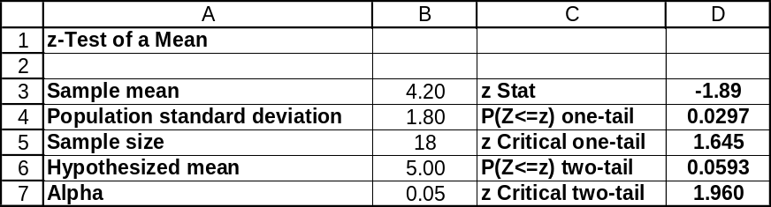

10.31 p/a/m Null and alternative hypotheses:
H₀: μ = 2.5 (machine doesn't need maintenance) H₁: μ ≠ 2.5 (needs maintenance)
Level of significance: α = 0.01
Test results: = 2.509, n = 34 (known: σ = 0.027)
Calculated value of test statistic: 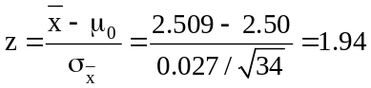
Critical values: z = -2.58 and z = 2.58 (in the normal distribution, the area between z = -2.58
and z = 2.58 is 0.99, and the sum of the two tail areas is 0.01).
Decision rule: Reject H₀ if the calculated z < -2.58 or > 2.58, otherwise do not reject.
Conclusion: Calculated test statistic falls in nonrejection region, do not reject H₀.
Decision: At the 0.01 level, the results suggest that the machine is not in need of maintenance and calibration. The mean diameter of the tubing appears to still be 2.5 inches. The difference between the hypothesized population mean and the sample mean is judged to have been merely the result of chance variation.
Using the standard normal distribution table, we can find the approximate p-value as twice the area to the right of z = 1.94. This is 2(1.0000 - 0.9738) = 2(0.0262) = 0.0524.

Given the summary data, we can also carry out this z-test using the Test Statistics workbook that accompanies Data Analysis Plus. For this two-tail test, the p-value (0.0519) is not less than the 0.01 level of significance being used to reach a conclusion, so the null hypothesis is not rejected. For a true null hypothesis, there is a 0.0519 probability that a sample mean this far away from 2.500 would occur by chance.
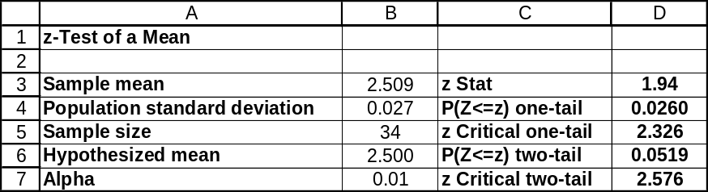

10.32 p/a/m Null and alternative hypotheses:
H₀: μ ≥ 3 (new booklet does not reduce assembly time) H₁: μ < 3 (reduces assembly time)
Level of significance: α = 0.05
Test results: = 2.90, n = 15 (known: σ = 0.20 and the population is normally distributed)
Calculated value of test statistic: 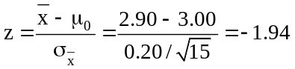
Critical value: z = -1.645 (in the normal distribution the area to the left of z = -1.645 is 0.05).
Decision rule: Reject H₀ if the calculated z < -1.645, otherwise do not reject.
Conclusion: Calculated test statistic falls in rejection region, reject H₀.
Decision: At the 0.05 level, the new booklet appears to be effective in reducing the time for an
inexperienced kit builder to assemble the device. The mean time for assembly with the new booklet is less than 3 hours.
Using the standard normal distribution table, we can find the approximate p-value as the area to the left of z = -1.94. This is 0.0262.

Given the summary data, we can also carry out this z-test using the Tests Statistics workbook that accompanies Data Analysis Plus. For this left-tail test, the p-value (0.0264) is less than the 0.05 level of significance being used to reach a conclusion, so the null hypothesis is rejected. For a true null hypothesis, there is only a 0.0264 probability that a sample mean this much less than 3.00 hours would occur by chance.
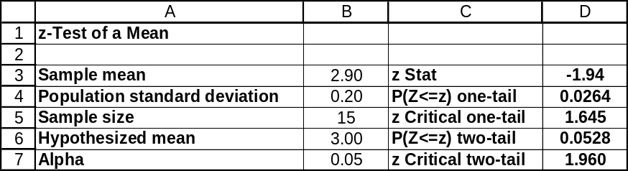

10.33 p/c/m The null and alternative hypotheses are H₀: μ = $10,526 and H₁: μ ≠ $10,526.
The Data Analysis Plus and Minitab results are shown below.
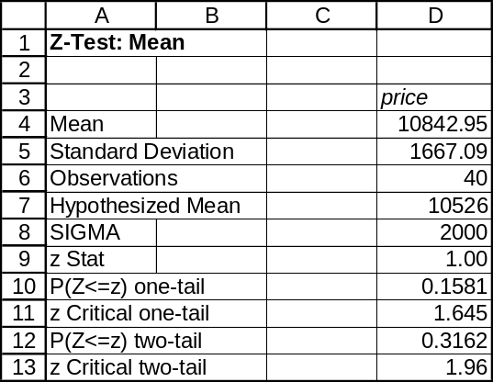

One-Sample Z: price

Test of mu = 10526 vs not = 10526
The assumed standard deviation = 2000

Variable N Mean StDev SE Mean 95% CI Z P
price 40 10843 1667 316 (10223, 11463) 1.00 0.316

For this two-tail test, the p-value (0.316) is not less than the 0.05 level of significance being used to reach a conclusion, so the null hypothesis is not rejected. At this level of significance, we conclude that the mean price for home office remodeling in this region could be the same as the mean price for the nation as a whole.

10.34 p/c/m The null and alternative hypotheses are H₀: μ = 70 pounds and H₁: μ ≠ 70 pounds
The Data Analysis Plus and Minitab results are shown below.
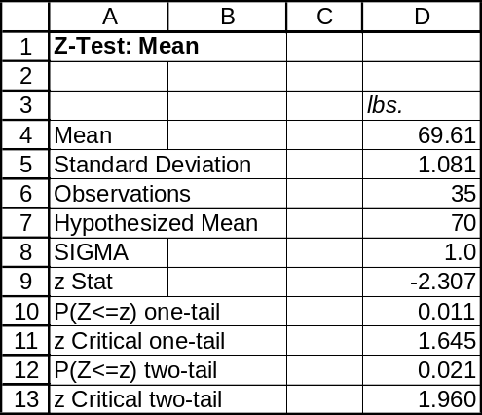

One-Sample Z: Lbs.

Test of mu = 70 vs mu not = 70
The assumed sigma = 1

Variable N Mean StDev SE Mean
Lbs. 35 69.610 1.081 0.169

Variable 95.0% CI Z P
Lbs. ( 69.279, 69.941) -2.31 0.021

For this two-tail test, the p-value (0.021) is less than the 0.05 level of significance being used to reach a conclusion, so the null hypothesis is rejected. At this level of significance, we conclude that the mean fill weight for the machine could be something other than 70.0 pounds. For a true null hypothesis, there would be only a 0.021 probability of obtaining a sample mean this far away from 70.0 pounds just by chance.

10.35 d/p/m
a. Do not reject H₀ since 170 is in the 90% confidence interval given.
b. Reject H₀ since 110 is not in the 90% confidence interval given.
c. Do not reject H₀ since 130 is in the 90% confidence interval given.
d. Reject H₀ since 200 is not in the 90% confidence interval given.

10.36 c/a/m From exercise 10.27, = 458.0, σ = 20.5, n = 35, the critical z values for a two-tail test at the α = 0.05 level are z = -1.96 and z = 1.96, and the hypothesis test is H₀: μ = 450 versus H₁: μ ≠ 450. The 95% confidence interval for μ is:
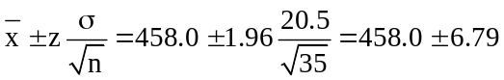, or from 451.21 to 464.79
Since 450 is not in the 95% confidence interval for μ found above, the population mean is probably not equal to 450. In exercise 10.27, the null hypothesis was rejected and we concluded that the population mean is not equal to 450. Therefore, the conclusion using the confidence interval is the same as the conclusion from the hypothesis test. The confidence interval can also be obtained using the Estimators workbook that accompanies Data Analysis Plus, as shown below.
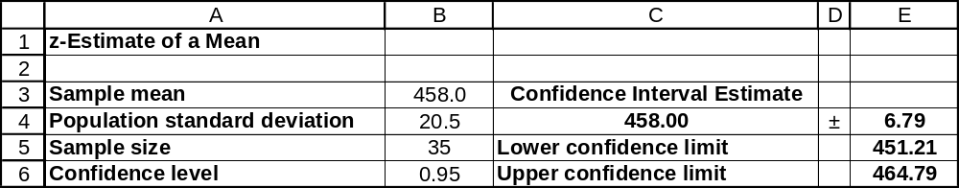

10.37 c/a/m From exercise 10.29, = 2.025 inches, σ = 0.070 inches, n = 35, the critical z values for a two-tail test at the α = 0.01 level are z = -2.58 and z = 2.58, and the hypothesis test is H₀: μ = 2.000 versus H₁: μ ≠ 2.000. The 99% confidence interval for μ is:
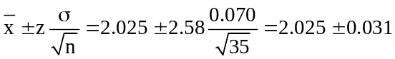, or from 1.994 to 2.056
Since 2.000 is within the 99% confidence interval for μ found above, the population mean could be equal to 2.000. In exercise 10.29, the null hypothesis was not rejected and we concluded that the population mean could be 2.000. Therefore, the conclusion using the confidence interval is the same as the conclusion from the hypothesis test. The confidence interval can also be obtained using the Estimators workbook that accompanies Data Analysis Plus, as shown below. Because it does not rely on the printed standard normal table (with its gaps between listed values), this interval is more accurate, and has lower and upper limits of 1.995 inches and 2.055 inches, respectively.
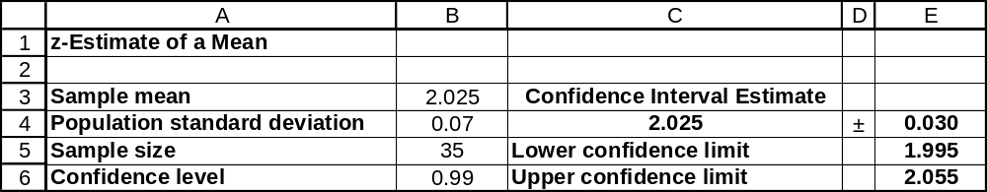

10.38 c/a/m From exercise 10.31, = 2.509 inches, σ = 0.027 inches, n = 34, the critical z values for a two-tail test at the α = 0.01 level are z = -2.58 and z = 2.58, and the hypothesis test is H₀: μ = 2.500 versus H₁: μ ≠ 2.500. The 99% confidence interval for μ is:
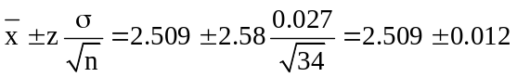, or from 2.497 to 2.521
Since 2.500 is within the 99% confidence interval for μ found above, the population mean could be equal to 2.500. In exercise 10.31, the null hypothesis was not rejected and we concluded that the population mean could be 2.500. Therefore, the conclusion using the confidence interval is the same as the conclusion from the hypothesis test. The confidence interval can also be obtained using the Estimators workbook that accompanies Data Analysis Plus, as shown below.
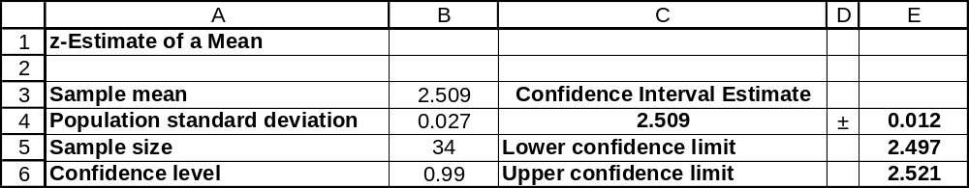

10.39 d/p/e The t statistic should be used in carrying out a hypothesis test for the mean when σ is unknown. When n < 30, we must assume the population is approximately normally distributed.

10.40 c/a/m Null and alternative hypotheses: H₀: μ = 24.0 H₁: μ ≠ 24.0
Level of significance: α = 0.01
Test results: = 25.9, s = 4.2, n = 40
Calculated value of test statistic: 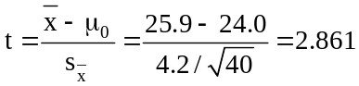
Critical values: t = -2.708 and t = 2.708 For this test, α = 0.01 and d.f. = (n - 1) = (40 - 1) = 39.
Referring to the 0.01/2 = 0.005 column and the 39th row of the t table, the critical values are t = -2.708 and t = 2.708.
Decision rule: Reject H₀ if the calculated t < -2.708 or > 2.708, otherwise do not reject.
Conclusion: Calculated test statistic falls in rejection region, reject H₀.
Decision: At the 0.01 level, the results suggest that the population mean is not equal to 24.0.

10.41 c/a/m Null and alternative hypotheses: H₀: μ ≥ 90.0 H₁: μ < 90.0
Level of significance: α = 0.05
Test results: = 82.0, s = 20.5, n = 15 (Note: population is approximately normally distributed.)
Calculated value of test statistic: 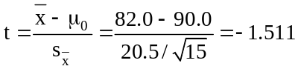
Critical value: t = -1.761. For this test, α = 0.05 and d.f. = (n - 1) = (15 - 1) = 14. Referring to the 0.05 column and the 14th row of the t table, the critical value is t = -1.761.
Decision rule: Reject H₀ if the calculated t < -1.761, otherwise do not reject.
Conclusion: Calculated test statistic falls in nonrejection region, do not reject H₀.
Decision: At the 0.05 level, the results suggest that the population mean could be at least 90.0.
The sample mean could have been this low merely by chance.
Given the summary data, we can also carry out this test using the Test Statistics workbook that accompanies Data Analysis Plus. In this left-tail test, the p-value (0.076) is not less than 0.05, so we do not reject the null hypothesis.
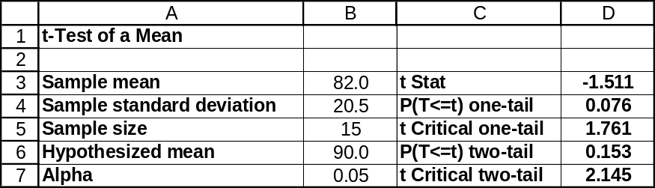

10.42 p/a/m Null and alternative hypotheses:
H₀: μ ≤ 9.0 (employees' cars no older than national average) H₁: μ > 9.0 (cars are older)
Level of significance: α = 0.01
Test results: = 10.4, s = 3.1, n = 34
Calculated value of test statistic: 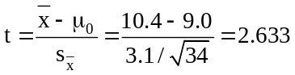
Critical value: t = 2.445 For this test, α = 0.01 and d.f. = (n - 1) = (34 - 1) = 33. Referring to the 0.01 column and the 33rd row of the t table, the critical value is t = 2.445.
Decision rule: Reject H₀ if the calculated t > 2.445, otherwise do not reject.
Conclusion: Calculated test statistic falls into the rejection region, reject H₀.
Decision: At the 0.01 level, we conclude that the average age of cars driven to work by the plant's employees could be more than the national average of 9.0 years.
Given the summary data, we can also carry out this test using the Test Statistics workbook that
accompanies Data Analysis Plus. In this right-tail test, the p-value (0.006) is less than 0.05, so we are
able to reject the null hypothesis.
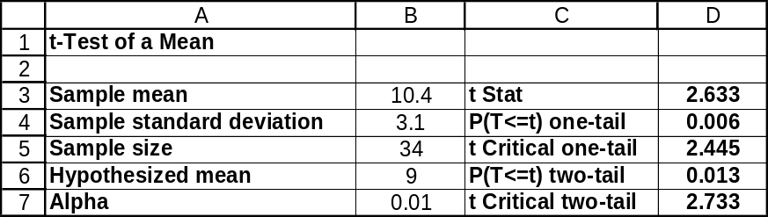

10.43 p/a/m Null and alternative hypotheses:
H₀: μ = 464 (the average flight is 464 miles, the value reported by the industry association) and
H₁: μ ≠ 464 (the average flight is not 464 miles) Level of significance: α = 0.05
Test results: = 479.6, s = 42.8, n = 30
Calculated value of test statistic: 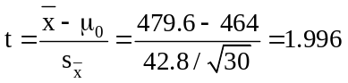
Critical values: t = -2.045 and t = 2.045 For this test, α = 0.05 and d.f. = (n - 1) = (30 - 1) = 29.
Referring to the 0.05/2 = 0.025 column and the 29th row of the t table, the critical values are t = -2.045 and t = 2.045.
Decision rule: Reject H₀ if the calculated t < -2.045 or > 2.045, otherwise do not reject.
Conclusion: Calculated test statistic falls in nonrejection region, do not reject H₀.
Decision: At the 0.05 level, the results do not cause us to doubt that the average length of a flight by regional airlines in the U.S. is the reported value, 464 miles. The difference between the hypothesized population mean and the sample mean is judged to have been merely the result of chance variation.
Given the summary data, we can also carry out this test using the Test Statistics workbook that accompanies Data Analysis Plus. In this two-tail test, the p-value (0.055) is not less than 0.05, so we do not reject the null hypothesis.
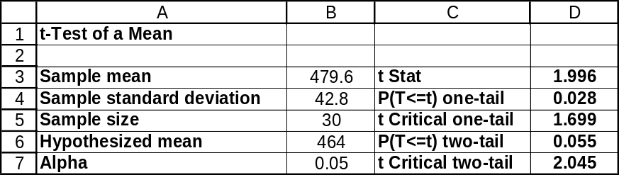
10.44 p/a/m Null and alternative hypotheses:
H₀: μ = 1.65 (the mean daily coffee consumption in this city is the same as for all U.S. residents)
H₁: μ ≠ 1.65 (the mean daily coffee consumption in this city differs from the overall U.S.)
Level of significance: α = 0.05
Test results: = 1.84, s = 0.85, n = 38
Calculated value of test statistic: 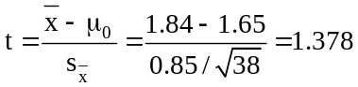
Critical values: t = -2.026 and t = 2.026 For this test, α = 0.05 and d.f. = (n - 1) = (38 - 1) = 37. Referring to the 0.05/2 = 0.025 column and the 37th row of the t table, the critical values are t = -2.026 and t = 2.026.
Decision rule: Reject H₀ if the calculated t < -2.026 or > 2.026, otherwise do not reject.
Conclusion: Calculated test statistic falls in nonrejection region, do not reject H₀.
Decision: At the 0.05 level, the mean daily coffee consumption for the residents of this North Carolina city does not differ significantly from their counterparts across the nation. The difference between the hypothesized population mean and the sample mean is judged to have been merely the result of chance variation.
Given the summary data, we can also carry out this test using the Test Statistics workbook that accompanies Data Analysis Plus. In this two-tail test, the p-value (0.177) is not less than 0.05, so we do not reject the null hypothesis.
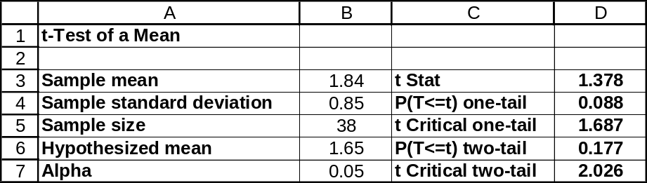

10.45 p/a/m Null and alternative hypotheses:
H₀: μ = 150 (Taxco's assertion is accurate) H₁: μ ≠ 150 (assertion is not accurate)
Level of significance: α = 0.10
Test results: = 125, s = 43, n = 12 (assumed: population is approximately normally distributed)
Calculated value of test statistic: 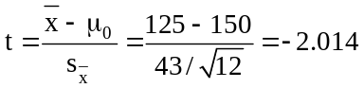
Critical values: t = -1.796 and t = 1.796 For this test, α = 0.10 and d.f. = (n - 1) = (12 - 1) = 11. Referring to the 0.10/2 = 0.05 column and the 11th row of the t table, the critical values are t = -1.796 and t = 1.796.
Decision rule: Reject H₀ if the calculated t < -1.796 or > 1.796, otherwise do not reject.
Conclusion: Calculated test statistic falls in rejection region, reject H₀.
Decision: At the 0.10 level, the results suggest that Taxco's assertion that the mean refund for those customers who received refunds last year was $150 is not accurate.
Given the summary data, we can also carry out this test using the Test Statistics workbook that accompanies Data Analysis Plus. In this two-tail test, the p-value (0.069) is less than 0.10, so we are able to reject the null hypothesis.
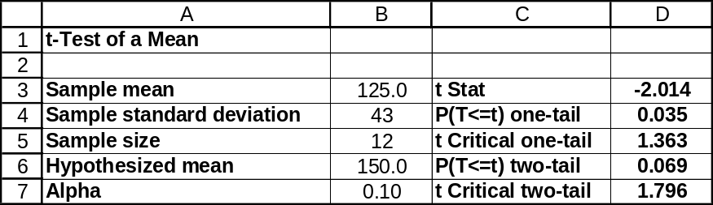

10.46 p/a/m Null and alternative hypotheses:
H₀: μ = 8.7 (mean length of membership is 8.7 years) H₁: μ ≠ 8.7 (mean length is not 8.7 yrs.)
Level of significance: α = 0.05
Test results: = 7.2, s = 2.5, n = 15 (assumed: population is approximately normally distributed)
Calculated value of test statistic: 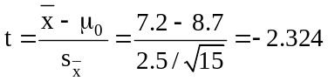
Critical values: t = -2.145 and t = 2.145 For this test, α = 0.05 and d.f. = (n - 1) = (15 - 1) = 14. Referring to the 0.05/2 = 0.025 column and the 14th row of the t table, the critical values are t = -2.145 and t = 2.145.
Decision rule: Reject H₀ if the calculated t < -2.145 or > 2.145, otherwise do not reject.
Conclusion: Calculated test statistic falls in rejection region, reject H₀.
Decision: At the 0.05 level, the results suggest that the actual mean length of membership may be some value other than 8.7 years.
Given the summary data, we can also carry out this test using the Test Statistics workbook that accompanies Data Analysis Plus. In this two-tail test, the p-value (0.036) is less than 0.05, so we are able to reject the null hypothesis.
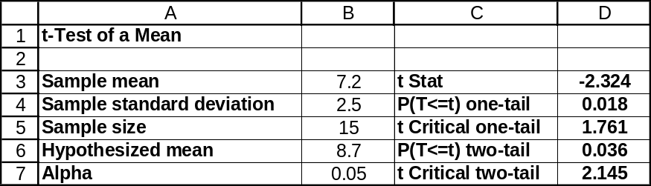

10.47 p/a/d Null and alternative hypotheses:
H₀: μ ≤ 80 (the mean of cash sales is no more than $80)
H₁: μ > 80 (the mean of cash sales is greater than $80)
Level of significance: α = 0.05
Test results: = 91, s = 21, n = 20
Calculated value of test statistic: 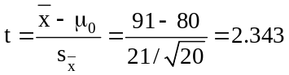
Critical value: t = 1.729 For this test, α = 0.05 and d.f. = (n - 1) = (20 - 1) = 19. Referring to the 0.05 column and the 19th row of the t table, the critical value is t = 1.729.
Decision rule: Reject H₀ if the calculated t > 1.729, otherwise do not reject.
Conclusion: Calculated test statistic falls in rejection region, reject H₀.
Decision: At the 0.05 level, it appears that the agent's suspicion is confirmed. The mean of the scrap metal dealer's cash sales appears to exceed $80.
Given the summary data, we can also carry out this test using the Test Statistics workbook that accompanies Data Analysis Plus. In this right-tail test, the p-value (0.015) is less than 0.05, so we are able to reject the null hypothesis.
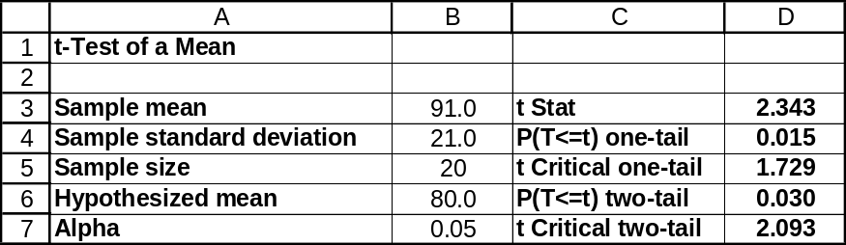

10.48 p/a/m Null and alternative hypotheses:
H₀: μ ≤ 1478 (the average earnings at this university is not higher than the national mean)
H₁: μ > 1478 (the average earnings at this university is higher than the national mean)
Level of significance: α = 0.05
Test results: = 1503, s = 210, n = 45
Calculated value of test statistic: 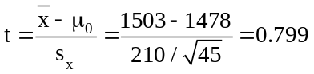
Critical value: t = 1.680 For this test, α = 0.05 and d.f. = (n - 1) = (45 - 1) = 44. Referring to the 0.05 column and the 44th row of the t table, the critical value is t = 1.680.
Decision rule: Reject H₀ if the calculated t > 1.680, otherwise do not reject.
Conclusion: Calculated test statistic falls in nonrejection region, do not reject H₀.
Decision: At the 0.05 level, the results suggest that the average earnings of this university's work-study students are not higher than the national average of $1478. The sample mean could have been this high merely by chance.
Given the summary data, we can also carry out this test using the Test Statistics workbook that accompanies Data Analysis Plus. In this right-tail test, the p-value (0.214) is not less than 0.05, so we are not able to reject the null hypothesis.
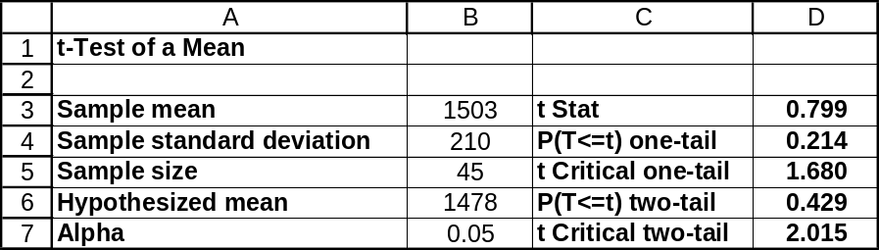

10.49 p/a/m Null and alternative hypotheses: H₀: μ = $640,000 and H₁: μ ≠ $640,000
The exercise can be solved by hand, but we will use the computer and the Test Statistics workbook that accompanies Data Analysis Plus. In this two-tail test, the p-value (0.147) is not less than 0.05, so we do not reject the null hypothesis. At the 0.05 level of significance, the mean for the older households in this region may be the same as the national mean.
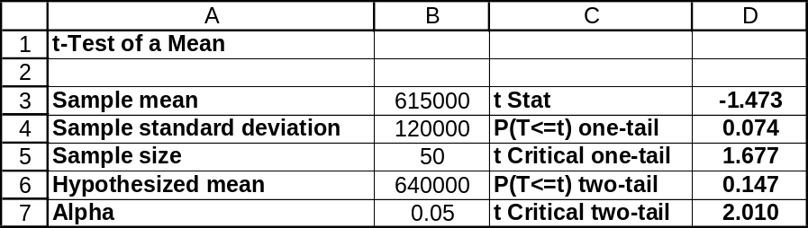

10.50 p/a/m Using the Estimators workbook that accompanies Data Analysis Plus, we obtain the 95% confidence interval shown below. We are 95% confident the mean for older households in this region is within the interval from $580,896 to $649,104. Because the hypothesized mean for this region ($640,000) is within the interval, we conclude that the mean for this region could be $640,000. This is the same conclusion reached in the hypothesis test of exercise 10.49.
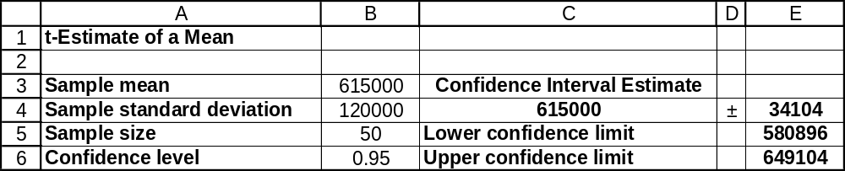

10.51 p/a/m Null and alternative hypotheses: H₀: μ ≥ 4000 hours and H₁: μ < 4000 hours
The exercise can be solved by hand, but we will use the computer and the Test Statistics workbook that accompanies Data Analysis Plus. In this left-tail test, the p-value (0.019) is less than 0.025, so we reject H₀ and conclude that the conditions may be having an adverse effect on bulb life.
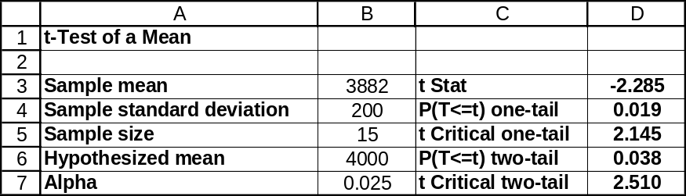

10.52 p/a/m Null and alternative hypotheses: H₀: μ = 93 minutes and H₁: μ ≠ 93 minutes
The exercise can be solved by hand, but we will use the computer and the Test Statistics workbook
that accompanies Data Analysis Plus. In this two-tail test, the p-value (0.033) is less than 0.05, so we
reject H₀ and conclude that the population mean is some value other than 93 minutes.
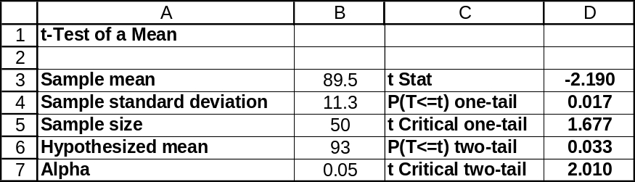

10.53 p/a/m Using the Estimators workbook, we obtain the 95% confidence interval shown below. We are 95% confident the population mean is within the interval from 86.29 to 92.71 seconds.
Because the hypothesized population mean (93 minutes) is not within this interval, we conclude that the actual population mean must be some value other than 93 minutes. This is the same conclusion reached in the hypothesis test of exercise 10.52.
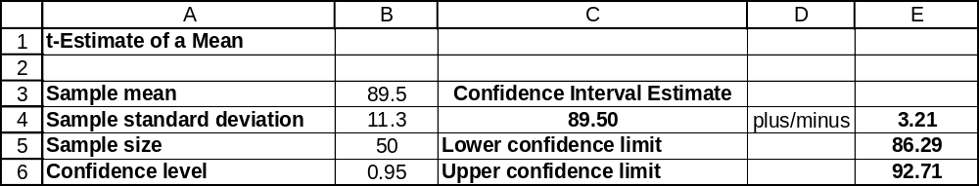

10.54 p/a/m Null and alternative hypotheses: H₀: μ = 38 minutes and H₁: μ ≠ 38 minutes
The exercise can be solved by hand, but we will use the computer and the Test Statistics workbook that accompanies Data Analysis Plus. In this two-tail test, the p-value (0.085) is less than 0.10, so we reject H₀ and conclude that the actual population mean time for completion might be some value other than 38 minutes.
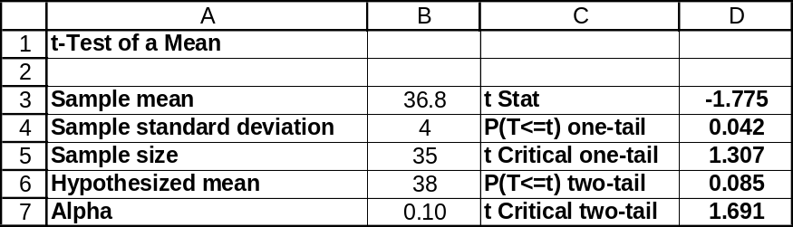

10.55 p/a/m Using the Estimators workbook, we obtain the 90% confidence interval shown below. We are 90% confident the population mean completion time is within the interval from 35.657 minutes to 37.943 minutes. Because the hypothesized population mean (38 minutes) is not within this interval, we conclude that the actual population mean must be some value other than 38 minutes. This is the same conclusion reached in the hypothesis test of exercise 10.54.
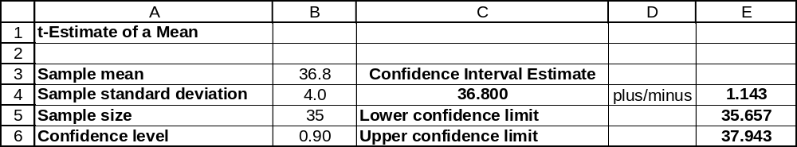

10.56 p/c/m The null and alternative hypotheses are H₀: μ ≤ $57 and H₁: μ > $57.
The Data Analysis Plus and Minitab results are shown below.
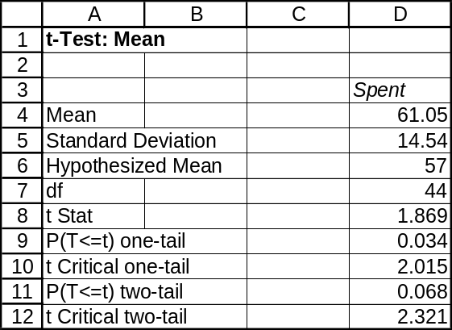

One-Sample T: Spent
Test of mu = 57 vs > 57
2.5%
2.5%
Lower
Variable N Mean StDev SE Mean Bound T P
Spent 45 61.05 14.54 2.17 65.42 1.87 0.034

For this right-tail test, the p-value (0.034) is not less than the 0.025 level of significance being used to reach a conclusion, so the null hypothesis is not rejected. At this level of significance, we conclude that the mean mall shopping expenditure for teens in this area may not be any higher than for U.S. teens as a whole.
10.57 p/c/m The null and alternative hypotheses are H₀: μ = $817 and H₁: μ ≠ $817.
The Data Analysis Plus and Minitab results are shown below.
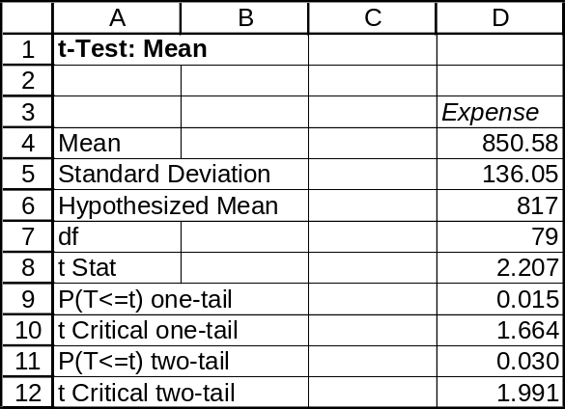

One-Sample T: Expense

Test of mu = 817 vs not = 817

Variable N Mean StDev SE Mean 95% CI T P
Expense 80 850.6 136.1 15.2 (820.3, 880.9) 2.21 0.030

For this two-tail test, the p-value (0.030) is less than the 0.05 level of significance being used to reach a conclusion, so the null hypothesis is rejected. If the North Carolina mean were really $817, there would be only a 0.030 probability of obtaining a sample mean this far away from $817. We conclude that the mean for North Carolina motorists is some value other than $817.

10.58 p/c/m As shown in the Minitab printout in the solution to exercise 10.57, the 95% confidence interval for the North Carolina mean is from $820.3 to $880.9. The hypothesized mean ($817) is not within the interval, so we conclude that the mean for North Carolina must be some value other than $817. This is the same conclusion that was reached in exercise 10.57.

10.59 d/p/e The normal distribution is a good approximation for the binomial distribution when nπ and n(1-π) are both ≥ 5.

10.60 c/a/m Null and alternative hypotheses: H₀: π = 0.40 H₁: π ≠ 0.40
Level of significance: α = 0.01
Test results: p = 0.34, n = 200
Calculated value of test statistic: 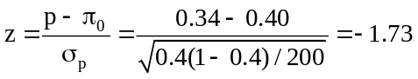
Critical values: z = -2.58 and z = 2.58
Decision rule: Reject H₀ if the calculated z < -2.58 or > 2.58, otherwise do not reject.
Conclusion: Calculated test statistic falls in nonrejection region, do not reject H₀.
Decision: At the 0.01 level, the results suggest that the population proportion could be 0.40.
The difference between the hypothesized population proportion and the sample proportion is judged to have been merely the result of chance variation.
Given the summary data, we can also use the Test Statistics workbook that accompanies Data Analysis Plus. For this two-tail test, the p-value (0.083) is not less than the 0.01 level of significance being used to reach a conclusion, so do not reject the null hypothesis.
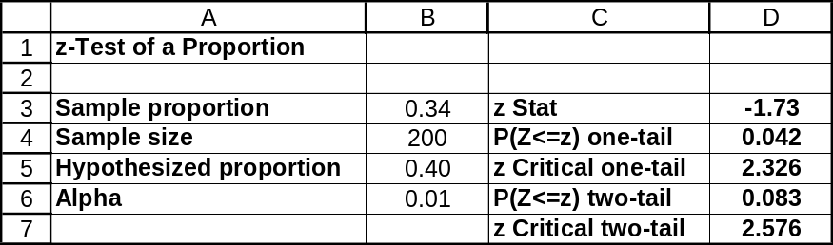

10.61 c/a/m Null and alternative hypotheses: H₀: π ≥ 0.50 H₁: π < 0.50
Level of significance: α = 0.05
Test results: p = 0.47, n = 1000
Calculated value of test statistic: 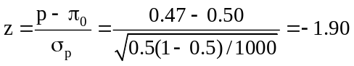
Critical value: z = -1.645
Decision rule: Reject H₀ if the calculated z < -1.645, otherwise do not reject.
Conclusion: Calculated test statistic falls in rejection region, reject H₀.
Decision: At the 0.05 level, the results suggest that the population proportion is less than 0.50.
Given the summary data, we can also use the Test Statistics workbook that accompanies
Data Analysis Plus. For this left-tail test, the p-value (0.029) is less than the 0.05 level of significance being used to reach a conclusion, so reject the null hypothesis.
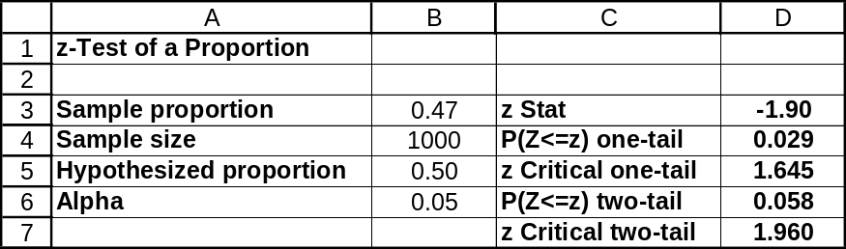

10.62 c/a/m Null and alternative hypotheses: H₀: π ≤ 0.60 H₁: π > 0.60
Level of significance: α = 0.025
Test results: p = 0.63, n = 700
Calculated value of test statistic: 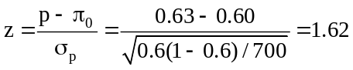
Critical value: z = 1.96
Decision rule: Reject H₀ if the calculated z > 1.96, otherwise do not reject.
Conclusion: Calculated test statistic falls in nonrejection region, do not reject H₀.
Decision: At the 0.025 level, the results suggest that the population proportion is no more than 0.60.
The sample proportion could have been this large merely by chance.

10.63 p/a/m Null and alternative hypotheses:
H₀: π ≤ 0.02 (the proportion of defectives is no more than 0.02)
H₁: π > 0.02 (the proportion of defectives is greater than 0.02)
Level of significance: We will use α = 0.05 in carrying out this right-tail test.
Test results: p = 0.04, n = 300
Calculated value of test statistic: 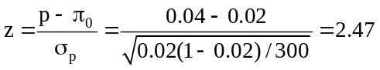
Critical value: z = 1.645
Decision rule: Reject H₀ if the calculated z > 1.645, otherwise do not reject.
Conclusion: Calculated test statistic falls in rejection region, reject H₀.
Decision: At the 0.05 level, the results suggest that the supplier's claim is not correct. The true percentage of defectives in the shipment appears to be greater than 2%.
Given the summary data, we can also use the Test Statistics workbook that accompanies
Data Analysis Plus. For this right-tail test, the p-value (0.007) is less than the 0.05 level of significance being used to reach a conclusion, so reject the null hypothesis.
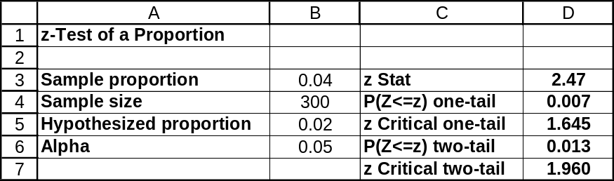

10.64 p/a/m Null and alternative hypotheses:
H₀: π = 0.15 (the proportion of juniors who apply for admission is 0.15)
H₁: π ≠ 0.15 (the proportion of juniors who apply for admission is not 0.15)
Level of significance: α = 0.05
Test results: p = 30/300 = 0.10, n = 300
Calculated value of test statistic: 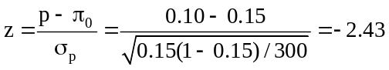
Critical values: z = -1.96 and z = 1.96
Decision rule: Reject H₀ if the calculated z < -1.96 or > 1.96, otherwise do not reject.
Conclusion: Calculated test statistic falls in rejection region, reject H₀.
Decision: At the 0.05 level, the results suggest that we should reject the director's claim. The true proportion of high school juniors to whom she sends university literature who eventually apply for admission is not 0.15.

10.65 p/a/m Null and alternative hypotheses:
H₀: π ≤ 0.05 (the proportion who violated the agreement is no more than 0.05)
H₁: π > 0.05 (the proportion who violated the agreement is more than 0.05)
Level of significance: α = 0.025
Test results: p = 0.08, n = 400
Calculated value of test statistic: 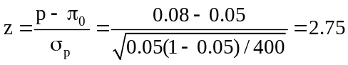
Critical value: z = 1.96
Decision rule: Reject H₀ if the calculated z > 1.96, otherwise do not reject.
Conclusion: Calculated test statistic falls in rejection region, reject H₀.
Decision: At the 0.025 level, the data do not support the human resource's director's claim that no more than 5% of employees hired in the past year have violated their pre-employment agreement not to use any of five illegal drugs.
Given the summary data, we can also use the Test Statistics workbook that accompanies
Data Analysis Plus. For this right-tail test, the p-value (0.003) is less than the 0.025 level of significance being used to reach a conclusion, so reject the null hypothesis.
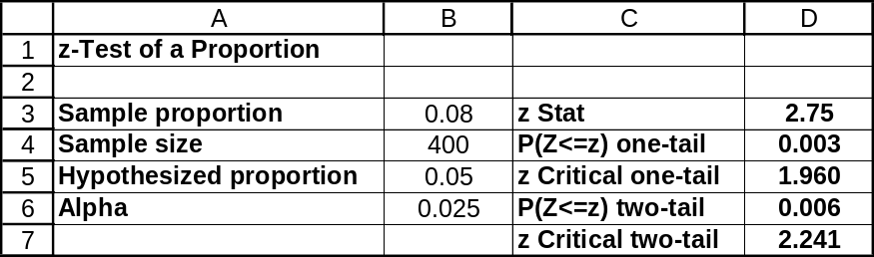

10.66 p/a/m Null and alternative hypotheses:
H₀: π = 0.65 (percentage who prefer electric heating has not changed)
H₁: π ≠ 0.65 (percentage who prefer electric heating has changed)
Level of significance: α = 0.05
Test results: p = 0.60, n = 200
Calculated value of test statistic: 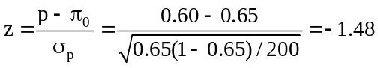
Critical values: z = -1.96 and z = 1.96
Decision rule: Reject H₀ if the calculated z < -1.96 or > 1.96, otherwise do not reject.
Conclusion: Calculated test statistic falls in nonrejection region, do not reject H₀.
Decision: At the 0.05 level, we cannot conclude that the percentage of residential energy consumers who prefer to heat with electricity instead of gas has changed from 65%. The difference between the hypothesized population proportion and the sample proportion is judged to have been merely the result of chance variation.
The p-value for this two-tail test is twice the area to the left of z = -1.48, or 2(0.0694) = 0.1388.
Because the p-value is not less than 0.05, we do not reject the null hypothesis. Using the Test Statistics workbook, the corresponding results are shown below.
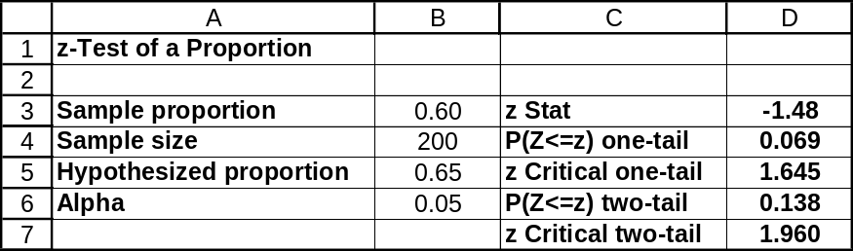

10.67 p/a/m Null and alternative hypotheses:
H₀: π ≤ 0.44 (the proportion passing on the first try has not increased)
H₁: π > 0.44 (the proportion passing on the first try has increased)
Level of significance: α = 0.05
Test results: p = 130/250 = 0.52, n = 250
Calculated value of test statistic: 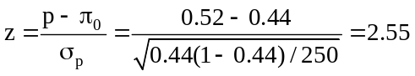
Critical value: z = 1.645
Decision rule: Reject H₀ if the calculated z > 1.645, otherwise do not reject.
Conclusion: Calculated test statistic falls in rejection region, reject H₀.
Decision: At the 0.05 level, we can conclude that the proportion passing on the first try has increased from 0.44.
The p-value for this right-tail test is the area to the right of z = 2.55, or 1.0000 - 0.9946 = 0.0054. Because the p-value is less than 0.05, we reject the null hypothesis. Using the Test Statistics workbook, the corresponding results are shown below.
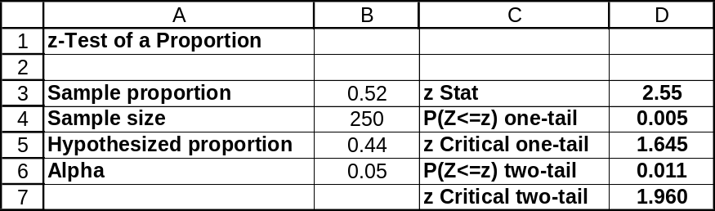

10.68 p/a/m Null and alternative hypotheses:
H₀: π ≥ 0.66 (the proportion who have purchased life insurance is at least 0.66)
H₁: π < 0.66 (the proportion who have purchased life insurance is less than 0.66)
Level of significance: α = 0.05
Test results: p = 0.56, n = 50
Calculated value of test statistic: 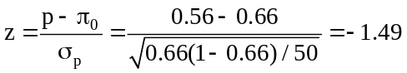
Critical value: z = -1.645
Decision rule: Reject H₀ if the calculated z < -1.645, otherwise do not reject.
Conclusion: Calculated test statistic falls in nonrejection region, do not reject H₀.
Decision: At the 0.05 level, the sample finding is not significantly lower than the 66% reported by the research firm for the U.S. overall.
The p-value for this left-tail test is the area to the left of z = -1.49, or 0.0681.
Because the p-value is not less than 0.05, we do not reject the null hypothesis. Using the Test Statistics workbook, the corresponding results are shown below.
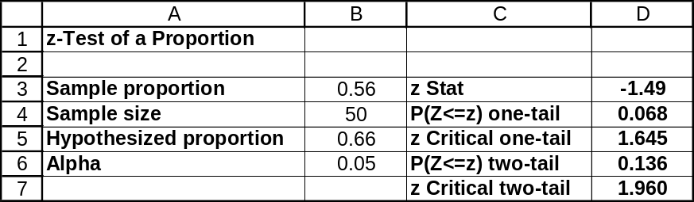

10.69 p/a/m The null and alternative hypotheses are H₀: π = 0.55 and H₁: π ≠ 0.55.
This solution can be obtained with a pocket calculator and formulas, but we will use the computer. As shown in the Test Statistics printout for this two-tail test, the p-value (0.014) is less than the 0.05 level of significance being used to reach a conclusion, so reject the null hypothesis. If the population proportion for this builder were really 0.55, there would be only a 0.014 probability of obtaining a sample proportion this far away from 0.55.
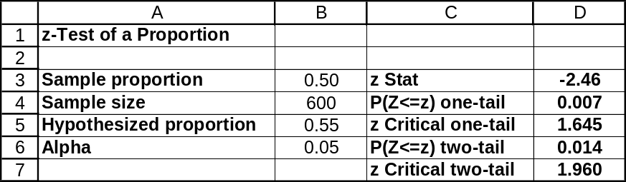

10.70 p/a/m This solution can be obtained with a pocket calculator and formulas, but we will use the computer. As shown in the Estimators printout below, the 95% confidence interval for the population proportion for this builder is from 0.460 to 0.540. The hypothesized proportion (0.55) is not within the interval, so we conclude that the proportion for this builder must be some value other than 0.55. This is the same conclusion that was reached in exercise 10.69.
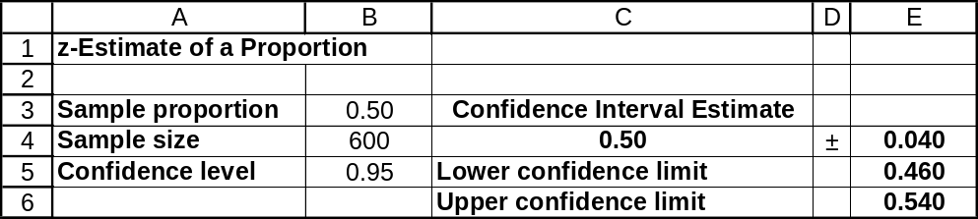

10.71 p/a/m The null and alternative hypotheses are H₀: π = 0.07 and H₁: π ≠ 0.07.
This solution can be obtained with a pocket calculator and formulas, but we will use the computer.
As shown in the Test Statistics printout for this two-tail test, the p-value (0.220) is not less than the 0.10 level of significance used to reach a conclusion, so we do not reject the null hypothesis.
The percentage of young women who are low-paid in this county might be the same as the percentage of young woman who are low-paid in the nation as a whole.
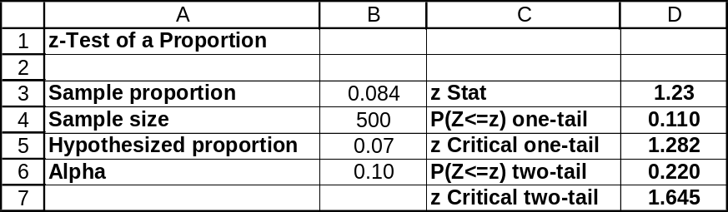

10.72 p/a/m This solution can be obtained with a pocket calculator and formulas, but we will use the computer. As shown in the Estimators printout below, the 90% confidence interval for the population proportion for this county is from 0.064 to 0.104. The hypothesized proportion (0.07) is within the interval, so we conclude that the population proportion of young women who are low-paid in this county could be 0.07. This is the same conclusion that was reached in exercise 10.71.
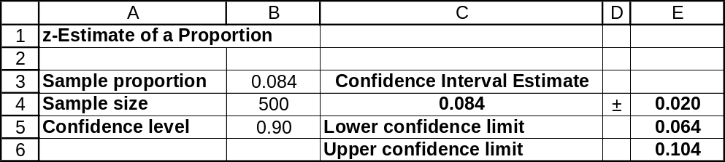

10.73 p/a/m The null and alternative hypotheses are H₀: π ≤ 0.50 and H₁: π > 0.50.
This solution can be obtained with a pocket calculator and formulas, but we will use the computer.
As shown in the Test Statistics printout for this right-tail test, the p-value (0.079) is not less than the 0.025 level of significance being used to reach a conclusion, so we do not reject the null hypothesis.
The sample proportion is not significantly greater than the 0.50 value we would expect simply by chance.
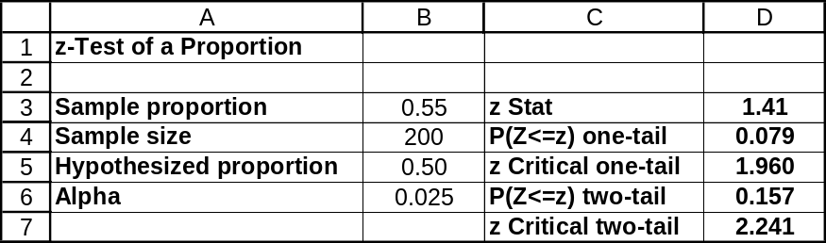

10.74 p/a/m The null and alternative hypotheses are H₀: π = 0.80 and H₁: π ≠ 0.80.
This solution can be obtained with a pocket calculator and formulas, but we will use the computer.
As shown in the Test Statistics printout for this two-tail test, the p-value (0.134) is not less than the 0.10 level of significance used to reach a conclusion, so we do not reject the null hypothesis.
The auditor’s performance does not differ significantly from the hypothesized 0.80 value.
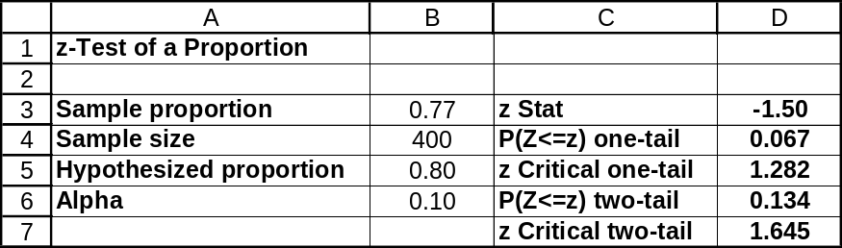

10.75 p/a/m This solution can be obtained with a pocket calculator and formulas, but we will use the computer. As shown in the Estimators printout below, the 90% confidence interval for the population proportion for this auditor is from 0.735 to 0.805. The hypothesized proportion (0.80) is within the interval, so we conclude that the population proportion for this auditor could be 0.80. This is the same conclusion that was reached in exercise 10.74.
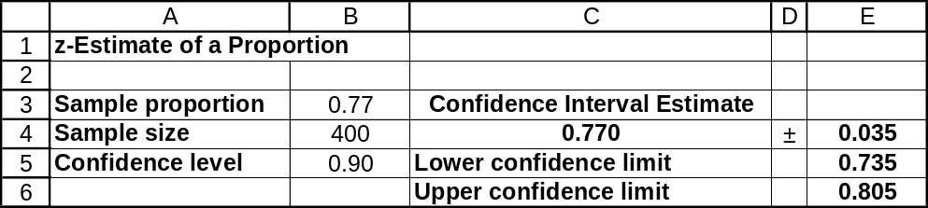

10.76 p/c/m The null and alternative hypotheses are H₀: π = 0.41 and H₁: π ≠ 0.41.
As shown in the Data Analysis Plus printout for this two-tail test, the p-value (0.151) is not less than the 0.10 level of significance, so we do not reject the null hypothesis. The graduation rate for male basketball players from this region could be the same as the rate for their counterparts nationwide.
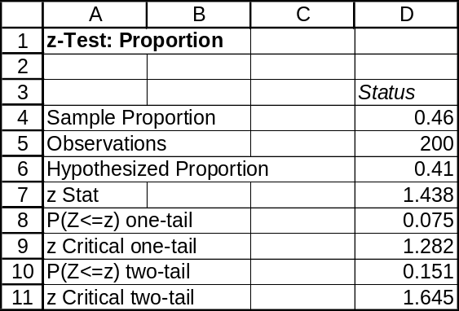

10.77 p/c/m As shown in the Data Analysis Plus printout, the 90% confidence interval for the population graduation rate for male basketball players from this region is from 0.402 to 0.518. Because the hypothesized proportion (0.41) is within this interval, we conclude that the population proportion for this region could be 0.41. This is the same as the conclusion that was reached in exercise 10.76.
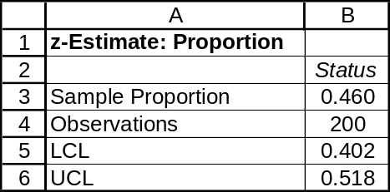

10.78 p/c/m The null and alternative hypotheses are H₀: π ≤ 0.35 and H₁: π > 0.35.
As shown in the Data Analysis Plus printout for this right-tail test, the p-value (0.035) is less than the 0.05 level of significance used to reach a conclusion, so we reject the null hypothesis. The high rate of visitors in the sample who went to the Can Do page is too large to have occurred by chance.
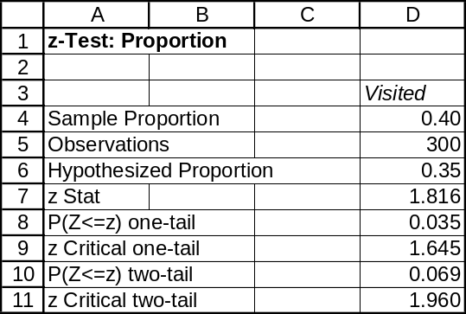

10.79 d/p/m The power of a test is the probability that the test will respond correctly by rejecting a false null hypothesis. By calculating the power of the test (1 - β) for several assumed values for the population mean and plotting the power versus the population mean, we arrive at the power curve. By looking at the power curve, you can get an idea of how powerful the hypothesis test is for different possible values of the population mean.

10.80 d/p/m The operating characteristic (OC) curve plots the probability that the hypothesis test will NOT reject the null hypothesis for assumed values for the population mean. The OC curve is the complement of the power curve. It is found by plotting β versus the population mean.

10.81 d/p/m Alpha has already been specified as 0.05 so, when the sample size is increased, α will stay the same and β will be decreased for the test.

10.82 p/a/d From exercise 10.31, σ = 0.027, n = 34, 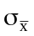 = 0.00463, the hypothesis test is
H₀: μ = 2.5 versus H₁: μ ≠ 2.5, and the decision rule is "Reject H₀ if the calculated test statistic
z < -2.58 or > 2.58."
First, get the decision rule in terms of .
Sample mean, , corresponding to critical z = -2.58 is 2.5 - 2.58(0.00463) = 2.488
Sample mean, , corresponding to critical z = 2.58 is 2.5 + 2.58(0.00463) = 2.512
The decision rule in terms of is: "Reject H₀ if < 2.488 or > 2.512"

Next, convert these sample means into z values using the true mean of μ = 2.52.
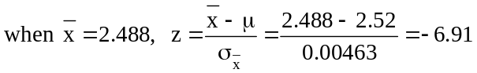
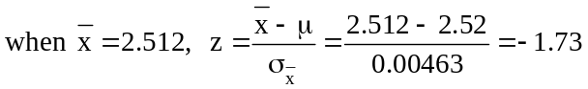
β = P(-6.91 ≤ z ≤ -1.73) = 0.0418 - 0.0000 = 0.0418
Power of the test = 1 - β = 1 - 0.0418 = 0.9582

Using the Beta-means workbook that accompanies Data Analysis Plus, we get a comparable result. Refer to the “Two-tail Test” worksheet and enter the requisite information into cells B3:B7.
The power of the test is shown in D6.
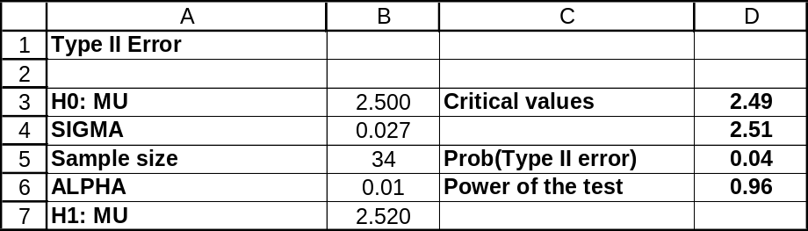

10.83 p/a/d From exercise 10.32, σ = 0.20, n = 15, = 0.05164, the hypothesis test is H₀: μ ≥ 3 versus H₁: μ < 3, and the decision rule is "Reject H₀ if the calculated z < -1.645."
First, get the decision rule in terms of .
Sample mean, , corresponding to critical z = -1.645 is 3 - 1.645(0.05164) = 2.915
The decision rule in terms of is: "Reject H₀ if < 2.915"
Next, convert the sample mean into a z value using the true mean of μ = 2.80.
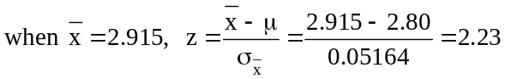
β = P(z ≥ 2.23) = 1.0000 - 0.9871 = 0.0129
Power of the test = 1 - β = 1- 0.0129 = 0.9871

Using the Beta-means workbook that accompanies Data Analysis Plus, we get a comparable result. Refer to the “Left-tail Test” worksheet and enter the requisite information into cells B3:B7.
The power of the test is shown in D5
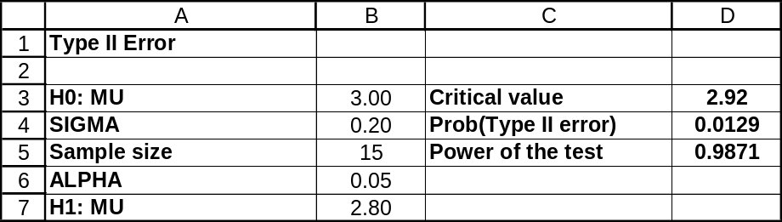

10.84 p/a/d From exercise 10.31, σ = 0.027, n = 34, and = 0.00463. From exercise 10.82, the decision rule in terms of is "Reject H₀ if < 2.488 or > 2.512."
Now, find 1 - β for each assumed true population mean given.
Given μ = 2.485:
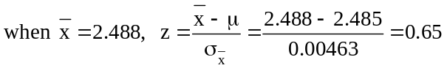
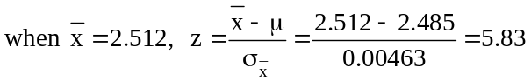
and 1 - β = 1 - P(0.65 ≤ z ≤ 5.83) = 1 - (1.0000 - 0.7422) = 1 - 0.2578 = 0.7422

Given μ = 2.490:
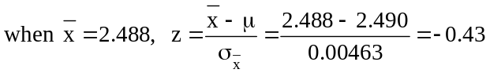
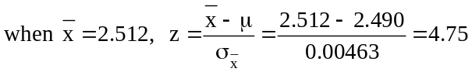
and 1 - β = 1 - P(-0.43 ≤ z ≤ 4.75) = 1 - (1.0000 - 0.3336) = 1 - 0.6664 = 0.3336

Given μ = 2.495:
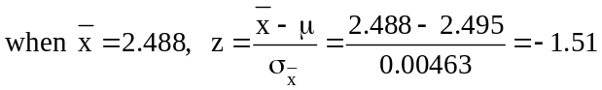
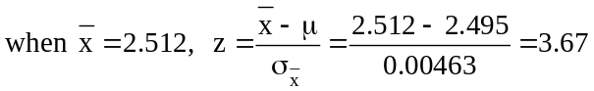
and 1 - β = 1 - P(-1.51 ≤ z ≤ 3.67) = 1 - (1.0000 - 0.0655) = 1 - 0.9345 = 0.0655

Given μ = 2.500:
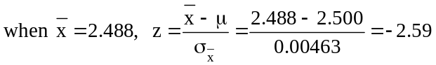
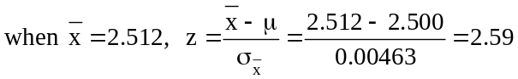
and 1 - β = 1 - P(-2.59 ≤ z ≤ 2.59) = 1 - (0.9952 - 0.0048) = 1 - 0.9904 = 0.0096

Given μ = 2.505:
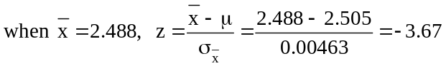
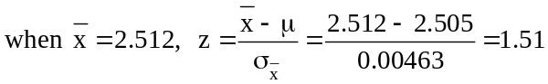
and 1 - β = 1 - P(-3.67 ≤ z ≤ 1.51) = 1 - (0.9345 - 0.0000) = 1 - 0.9345 = 0.0655

Given μ = 2.510:
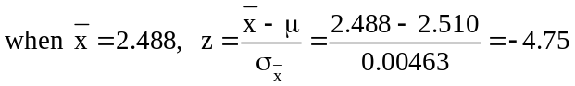
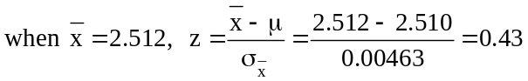
and 1 - β = 1 - P(-4.75 ≤ z ≤ 0.43) = 1 - (0.6664 - 0.0000) = 1 - 0.6664 = 0.3336

Given μ = 2.515:
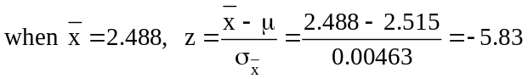
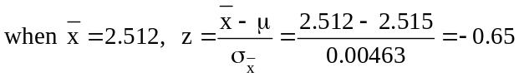
and 1 - β = 1 - P(-5.83 ≤ z ≤ -0.65) = 1 - (0.2578 - 0.0000) = 1 - 0.2578 = 0.7422

Using Minitab, the following results are obtained. The “Difference” column refers to the difference between the assumed actual μ and the value of μ in the null hypothesis.
For example, the Difference = -0.15 row shows the power of the test when the assumed actual mean is 2.485 inches compared to the hypothesized mean of 2.500 inches.

Power and Sample Size
1-Sample Z Test

Testing mean = null (versus not = null)
Calculating power for mean = null + difference
Alpha = 0.01 Sigma = 0.027

Sample
Difference Size Power
-0.015 34 0.7465
-0.010 34 0.3386
-0.005 34 0.0675
0.000 34 0.0100
0.005 34 0.0675
0.010 34 0.3386
0.015 34 0.7465

Using Excel to chart the power curve.
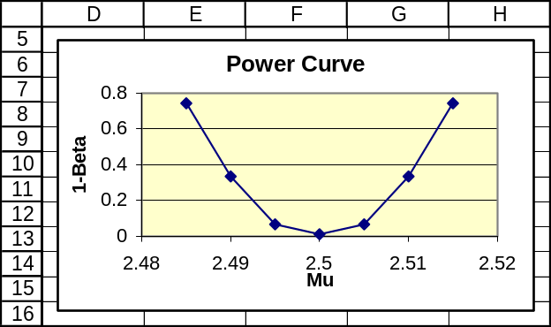

10.85 p/a/d From exercise 10.32, σ = 0.20, n = 15, and = 0.05164. From exercise 10.83, the decision rule in terms of is "Reject H₀ if < 2.915."
Now, find 1 - β for each assumed true population mean given.
Given μ = 2.80:
and 1 - β = 1 - P(z ≥ 2.23) = 1 - (1.0000 - 0.9871) = 1 - 0.0129 = 0.9871

Given μ = 2.85:
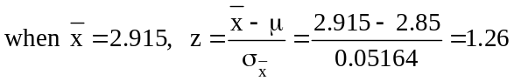
and 1 - β = 1 - P(z ≥ 1.26) = 1 - (1.0000 - 0.8962) = 1 - 0.1038 = 0.8962

Given μ = 2.90:
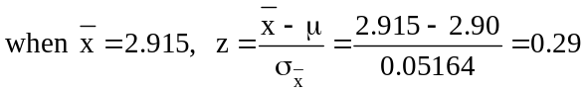
and 1 - β = 1 - P(z ≥ 0.29) = 1 - (1.0000 - 0.6141) = 1 - 0.3859 = 0.6141

Given μ = 2.95:
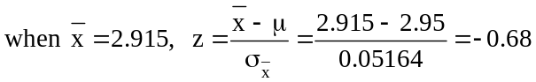
and 1 - β = 1 - P(z ≥ -0.68) = 1 - (1.0000 - 0.2483) = 1 - 0.7517 = 0.2483

Given μ = 3.00:
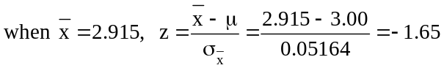
and 1 - β = 1 - P(z ≥ -1.65) = 1 - (1.0000 - 0.0495) = 1 - 0.9505 = 0.0495

Using Minitab, the following results are obtained. The “Difference” column refers to the difference between the assumed actual μ and the value of μ in the null hypothesis.
For example, the Difference = -0.20 row shows the power of the test when the assumed actual mean is 2.80 hours compared to the hypothesized mean of 3.00 hours.

Power and Sample Size
1-Sample Z Test

Testing mean = null (versus < null)
Calculating power for mean = null + difference
Alpha = 0.05 Sigma = 0.2

Sample
Difference Size Power
-0.20 15 0.9871
-0.15 15 0.8961
-0.10 15 0.6147
-0.05 15 0.2493
0.00 15 0.0500

Using Excel to chart the power curve.
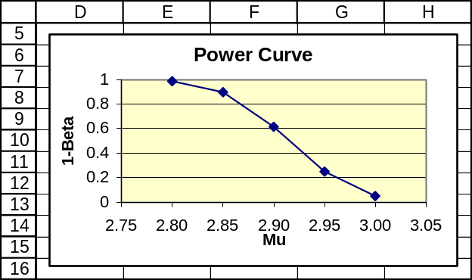

10.86 p/a/d From exercise 10.63, p = 0.04, n = 300, the hypothesis test is H₀: π ≤ 0.02 versus
H₁: π > 0.02, and the decision rule is "Reject H₀ if the calculated z > 1.645." The standard error of p can be calculated as:
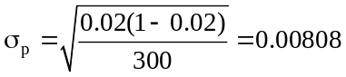
First, get the decision rule in terms of p.
Sample proportion corresponding to critical z = 1.645 is 0.02 + 1.645(0.00808) = 0.033
The decision rule in terms of p will be: "Reject H₀ if p > 0.033."
Now, find 1 - β for each assumed true population proportion given.

Given π = 0.02:
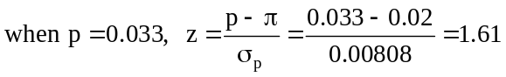
and 1 - β = 1 - P(z ≤ 1.61) = 1 - 0.9463 = 0.0537

Note: By definition, this should be 0.0500, but it differs due to rounding errors. See the Minitab note that follows the calculations.

Given π = 0.03:
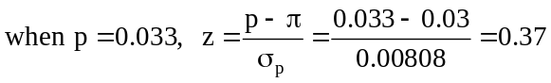
and 1 - β = 1 - P(z ≤ 0.37) = 1 - 0.6443 = 0.3557

Given π = 0.04:
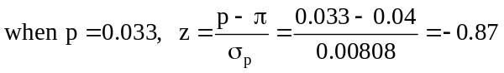
and 1 - β = 1 - P(z ≤ -0.87) = 1 - 0.1922 = 0.8078

Given π = 0.05:
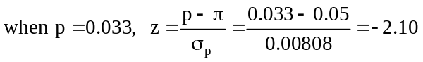
and 1 - β = 1 - P(z ≤ -2.10) = 1- 0.0179 = 0.9821

Given π = 0.06:
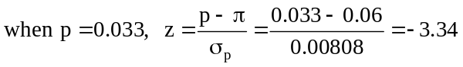
and 1 - β = 1 - P(z ≤ -3.34) = 1 - 0.0000 = 1.0000

Given π = 0.07:
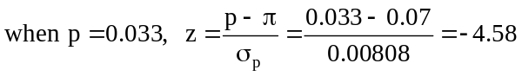
and 1 - β = P(z ≤ -4.58) = 1 - 0.0000 = 1.0000

Using Minitab, note that the “Alternative Proportion” column refers to the assumed actual π and the entries are in scientific notation – e.g., “2.00E-02” represents 2.00 x 10⁻², or 0.02. The Minitab results are much more accurate than the ones calculated above, largely due to our rounding in the quantities either leading to the calculation or resulting from it, including p, σ_{p}, and z.

Power and Sample Size
Test for One Proportion

Testing proportion = 0.02 (versus > 0.02)
Alpha = 0.05

Alternative Sample
Proportion Size Power
2.00E-02 300 0.0500
3.00E-02 300 0.3690
4.00E-02 300 0.7233
5.00E-02 300 0.9078
6.00E-02 300 0.9743
7.00E-02 300 0.9936

Using Excel to chart the power curve.
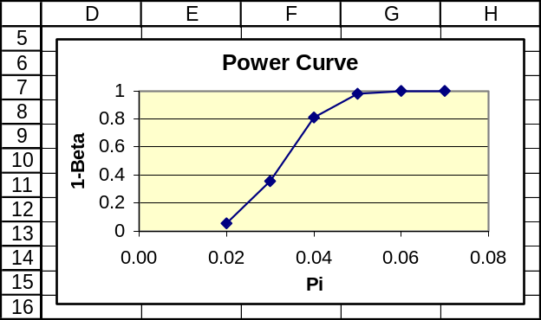

10.87 p/a/d H₀: π ≤ 0.02 versus H₁: π > 0.02 , with α = 0.01, n = 400, and the standard error of p calculated as:
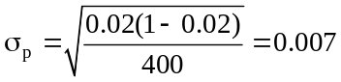
a. z = 2.33 for a right-tail area of 0.01 beneath the normal curve.
b. Getting the decision rule in terms of p: p = 0.02 + 2.33(0.007) = 0.036
and the decision rule is: "Reject H₀ if p > 0.036."
c. β = P(fail to reject a false H₀)

Given π = 0.02:
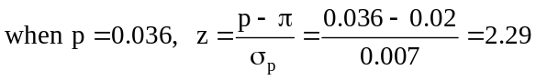
and β = P(z ≤ 2.29) = 0.9890

Given π = 0.03:
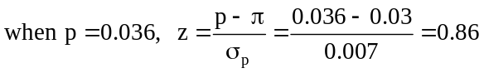
and β = P(z ≤ 0.86) = 0.8051

Given π = 0.04:
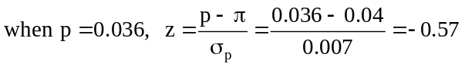
and β = P(z ≤ -0.57) = 0.2843

Given π = 0.05:
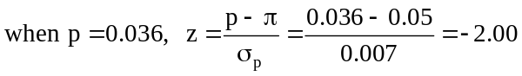
and β = P(z ≤ -2.00) = 0.0228

Given π = 0.06:
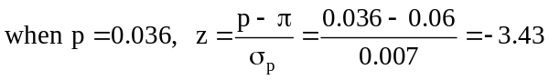
and β = P(z ≤ -3.43) = 0.0000

d. Using the calculations carried out in part c,
When π = 0.02, 1 - β = 1 - 0.9890 = 0.0110
When π = 0.03, 1 - β = 1 - 0.8051 = 0.1949
When π = 0.04, 1 - β = 1 - 0.2843 = 0.7157
When π = 0.05, 1 - β = 1 - 0.0228 = 0.9772
When π = 0.06, 1 - β = 1 - 0.0000 = 1.0000

Using Minitab, note that the “Alternative Proportion” column refers to the assumed actual π and the entries are in scientific notation -- e.g., “2.00E-02” represents 2.00 x 10⁻², or 0.02. The Minitab results are much more accurate than the ones calculated above, largely due to our rounding in the quantities either leading to the calculation or resulting from it, including p, σ_{p}, and z.

Power and Sample Size
Test for One Proportion

Testing proportion = 0.02 (versus > 0.02)
Alpha = 0.01

Alternative Sample
Proportion Size Power
2.00E-02 400 0.0100
3.00E-02 400 0.2306
4.00E-02 400 0.6477
5.00E-02 400 0.8959
6.00E-02 400 0.9771

Using Excel to chart the power curve.
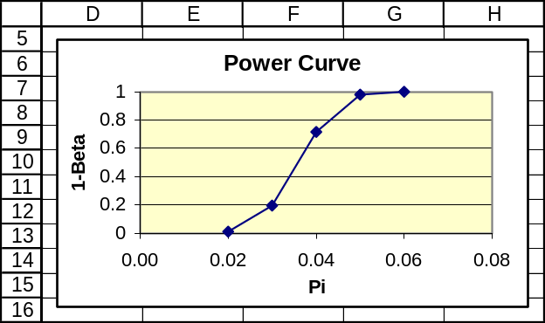

The operating characteristic curve.
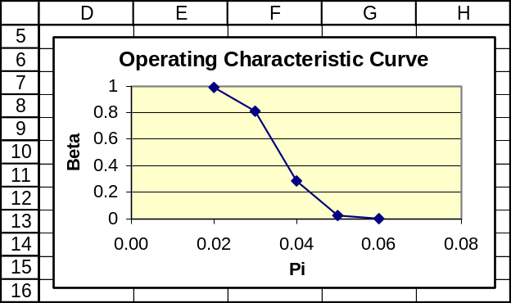

10.88 p/a/m From exercise 10.84,
When μ = 2.485, β = 0.2578 When μ = 2.505, β = 0.9345
When μ = 2.490, β = 0.6664 When μ = 2.510, β = 0.6664
When μ = 2.495, β = 0.9345 When μ = 2.515, β = 0.2578
When μ = 2.500, β = 0.9904

The operating characteristic curve is shown below:
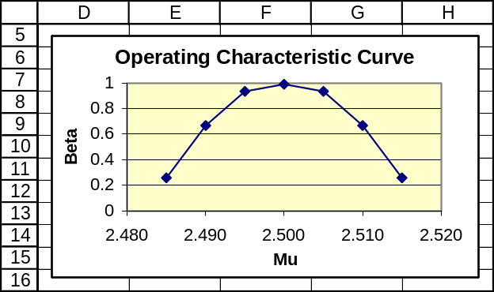

10.89 p/a/m From exercise 10.86,
When π = 0.02, β = 0.9463 When π = 0.05, β = 0.0179
When π = 0.03, β = 0.6443 When π = 0.06, β = 0.0000
When π = 0.04, β = 0.1922 When π = 0.07, β = 0.0000

The operating characteristic curve is shown below:
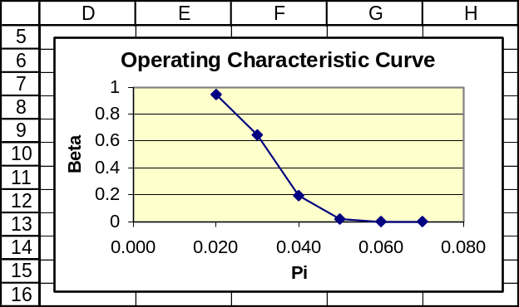

CHAPTER EXERCISES
10.90 d/p/m
a. For this situation, a left-tail test should be used since quality should now be improved.
The appropriate null and alternative hypotheses are H₀: π ≥ 0.05 and H₁: π < 0.05.
A left-tail test is appropriate since, if the quality is improved, the proportion of defectives would be smaller than 0.05.
b. For this situation, a two-tail test should be used. The appropriate null and alternative hypotheses are H₀: π = 0.55 and H₁: π ≠ 0.55. A two-tail test is appropriate since it is a nondirectional statement that could be rejected by an extreme result in either direction.
c. For this situation, a left-tail test should be used since a dealer would want to improve this value.
The appropriate null and alternative hypotheses are H₀: π ≥ 0.70 and H₁: π < 0.70.
A left-tail test is appropriate since, if the dealer improved the pre-delivery mechanical checks, the proportion of cars having 3 or more mechanical problems in the first 4 months of ownership should decrease.

10.91 d/p/m H₀: The employee has not taken drugs, and H₁: The employee has taken drugs
A Type I error will occur if we decide the employee has taken drugs but he really has not taken drugs.
A Type II error will occur if we decide the employee has not taken drugs but he really has taken drugs.

10.92 p/a/m Null and alternative hypotheses:
H₀: μ ≥ 1400 (the bolts are genuine) and H₁: μ < 1400 (the bolts are not genuine)
Level of significance: We will use the α = 0.05 level in carrying out this left-tail test.
Test results: = 1385, n = 20 (known: σ = 30 and the population is normally distributed)
Calculated value of test statistic: 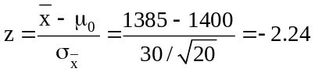
Critical value: z = -1.645 (beneath the normal curve, the area to the left of z = -1.645 is 0.05).
Decision rule: Reject H₀ if the calculated z < -1.645, otherwise do not reject.
Conclusion: Calculated test statistic falls in rejection region, reject H₀.
Decision: At the 0.05 level, it is possible that the bolts in the shipment might not be genuine since the mean tensile strength of the bolts is significantly less than 1400 pounds.
Given the information in this exercise, we could also use Excel worksheet template tmztest to obtain a solution. Just enter the values for n, , σ, and the hypothesized value for μ. The Excel printout is shown below, and the left-tail portion of the p-value section is in bold type for emphasis. The p-value for the test is 0.0127.
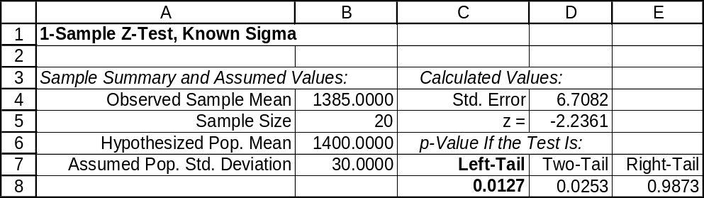

10.93 p/a/m Null and alternative hypotheses:
H₀: μ ≤ 45.4 (mean productivity has not increased) and H₁: μ > 45.4 (productivity has increased)
Level of significance: α = 0.01
Test results: = 47.5, n = 30 (known: σ = 4.5)
Calculated value of test statistic: 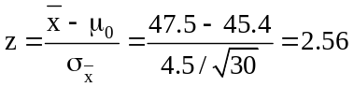
Critical value: z = 2.33 (beneath the normal curve, the area to the right of z = 2.33 is 0.01).
Decision rule: Reject H₀ if the calculated z > 2.33, otherwise do not reject.
Conclusion: Calculated test statistic falls in rejection region, reject H₀.
Decision: At the 0.01 level, it appears the efficiency expert's efforts have been successful, since the mean productivity is now significantly more than 45.4 units per hour.
Given the information in this exercise, we could also use Excel worksheet template tmztest to obtain a solution. Just enter the values for n, , σ, and the hypothesized value for μ. The Excel printout is shown below, and the right-tail portion of the p-value section is in bold type for emphasis. The p-value for the test is 0.0053.
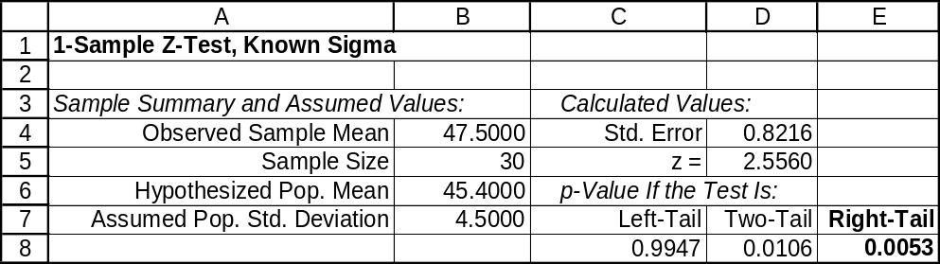

10.94 p/a/m
a. Null and alternative hypotheses:
H₀: μ = 3.13 (The average family size in this city is the same as the U.S. average)
H₁: μ ≠ 3.13 (The average family size in this city is not the same as the U.S. average)
Level of significance: α = 0.05
Test results: = 3.40, s = 1.10, n = 40
Calculated value of test statistic: 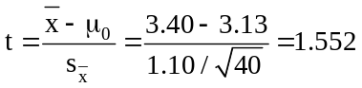
Critical values: t = -2.023 and t = 2.023 For this test, α = 0.05 and d.f. = (n - 1) = (40 - 1) = 39. Referring to the 0.05/2 = 0.025 column and the 39th row of the t table, the critical values are t = -2.023 and t = 2.023.
Decision rule: Reject H₀ if the calculated t < -2.023 or > 2.023, otherwise do not reject.
Conclusion: Calculated test statistic falls in nonrejection region, do not reject H₀.
Decision: At the 0.05 level, there is no reason to believe that the average family size in this city is different from the national average of 3.13 persons. The difference between the hypothesized population mean and the sample mean is judged to have been merely the result of chance.
b. The 95% confidence interval for μ is: 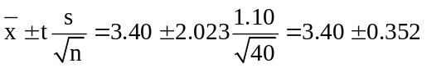,
or from 3.048 to 3.752. Since 3.13 is in the 95% confidence interval for μ found above, do not reject H₀. This is the same conclusion that was reached in part a.

Given the information in this exercise, we can also use the Test Statistics and Estimators workbooks that accompany Data Analysis Plus. The t-test result and the 95% confidence interval are shown in the printouts below. The p-value for this two-tail test is 0.129. The lower and upper limits of the 95% confidence interval are 3.048 and 3.752, respectively.
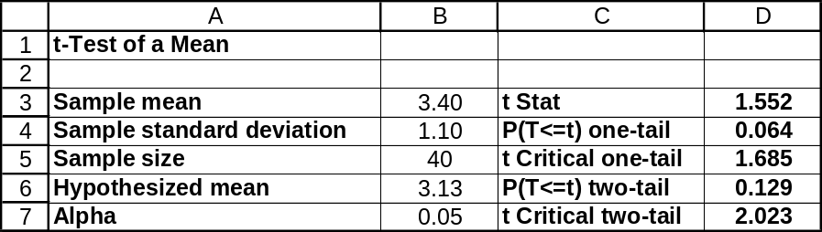
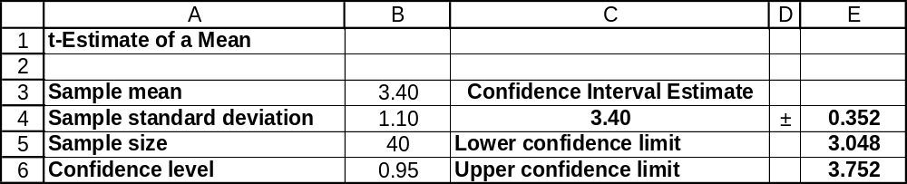

10.95 p/a/m
a. Null and alternative hypotheses:
H₀: μ = 235,600 (The average life insurance in this city is the same as the national average.)
H₁: μ ≠ 235,600 (The average life insurance in this city is not the same as the national average.)
Level of significance: α = 0.05
Test results: = 245,800, s = 25,500, n = 30
Calculated value of test statistic: 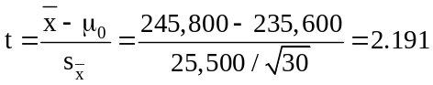
Critical values: t = -2.045 and t = 2.045 For this test, α = 0.05 and d.f. = (n - 1) = (30 - 1) = 29. Referring to the 0.05/2 = 0.025 column and the 29th row of the t table, the critical values are t = -2.045 and t = 2.045.
Decision rule: Reject H₀ if the calculated t < -2.045 or > 2.045, otherwise do not reject.
Conclusion: Calculated test statistic falls in rejection region, reject H₀.
Decision: At the 0.05 level, the average amount of life insurance in this city appears to be different from the national average of $235,600.
b. The 95% confidence interval for μ is: 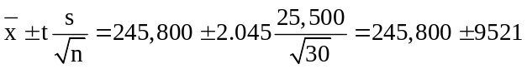,
or from $236,279 to $255,321. Since $235,600 is not in the 95% confidence interval for μ found above, reject H₀. This is the same conclusion that was reached in part a.

Given the information in this exercise, we can also use the Test Statistics and Estimators workbooks that accompany Data Analysis Plus. The t-test result and the 95% confidence interval are shown in the printouts below. The p-value for this two-tail test is 0.037.
The lower and upper limits of the 95% confidence interval are $236,278 and $255,322. Because they are not dependent on the printed t table and its inherent gaps between listed values, these confidence limits are more accurate than the ones calculated above.
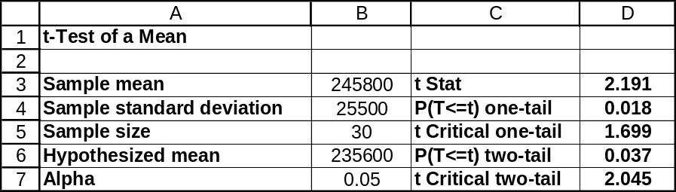
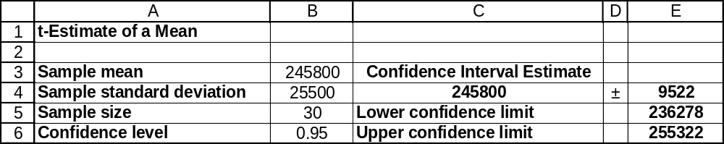

10.96 p/a/m Null and alternative hypotheses:
H₀: μ = 800 (shipment meets company specifications)
H₁: μ ≠ 800 (shipment does not meet company specifications)
Level of significance: α = 0.05
Test results: = 805, n = 30 (known: σ = 12)
Calculated value of test statistic: 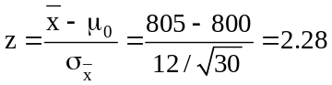
Critical values: z = -1.96 and z = 1.96
Decision rule: Reject H₀ if the calculated z < -1.96 or > 1.96, otherwise do not reject.
Conclusion: Calculated test statistic falls in rejection region, reject H₀.
Decision: At the 0.05 level, the superintendent's complaint appears to be justified since the mean
power consumption is significantly different from 800 watts.
Using the Test Statistics workbook that accompanies Data Analysis Plus, the corresponding printout is shown below. For this two-tail test, the p-value is 0.022.
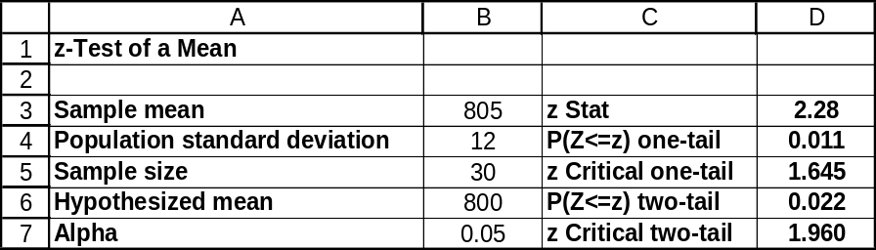

10.97 p/a/d Null and alternative hypotheses:
H₀: μ ≥ 356 (Mr. Jones is not too lenient with audits)
H₁: μ < 356 (Mr. Jones is too lenient with audits)
Level of significance: α = 0.05
Test results: = 322, s = 90, n = 30
Calculated value of test statistic: 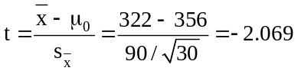
Critical value: t = -1.699 For this test, α = 0.05 and d.f. = (n - 1) = (30 - 1) = 29. Referring to the
0.05 column and the 29th row of the t table, the critical value is t = -1.699.
Decision rule: Reject H₀ if the calculated t < -1.699, otherwise do not reject.
Conclusion: Calculated test statistic falls in rejection region, reject H₀.
Decision: At the 0.05 level, the suspicions regarding Mr. Jones appear to be justified. The average amount of extra taxes collected by Mr. Jones appears to be less than $356.
Using the Test Statistics workbook that accompanies Data Analysis Plus, the corresponding printout is shown below. For this left-tail test, the p-value is 0.024.
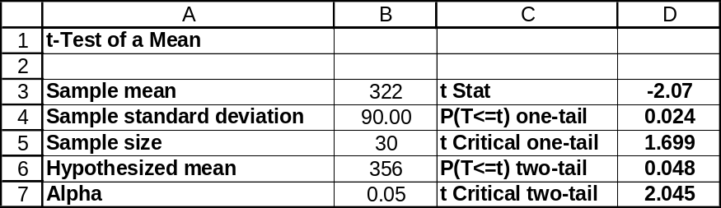

10.98 p/a/m Null and alternative hypotheses:
H₀: μ ≤ 0.40 (the official's claim is correct) and H₁: μ > 0.40 (the claim is not correct)
Level of significance: α = 0.05
Test results: = 0.46, s = 0.16, n = 35
Calculated value of test statistic: 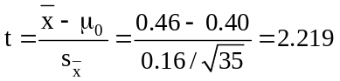
Critical value: t = 1.691 For this test, α = 0.05 and d.f. = (n - 1) = (35 - 1) = 34. Referring to the
0.05 column and the 34th row of the t table, the critical value is t = 1.691.
Decision rule: Reject H₀ if the calculated t > 1.691, otherwise do not reject.
Conclusion: Calculated test statistic falls in rejection region, reject H₀.
Decision: At the 0.05 level, we can reject the official's claim that the mean waiting time at exit booths from a toll road near the capital is no more than 0.40 minutes.
Using the Test Statistics workbook that accompanies Data Analysis Plus, the corresponding printout is shown below. For this right-tail test, the p-value is 0.017.
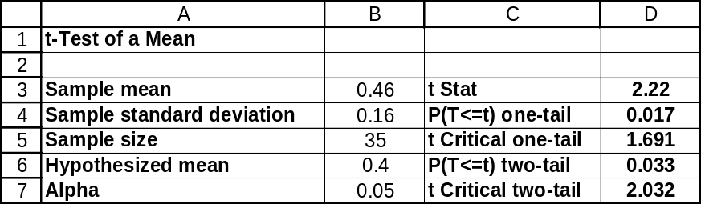

10.99 p/a/m Null and alternative hypotheses:
H₀: π ≤ 0.03 (This region does not have more of a burglary problem than the nation.)
H₁: π > 0.03 (This region does have more of a burglary problem than the nation.)
Level of significance: α = 0.05
Test results: p = 18/300 = 0.06, n = 300
Calculated value of test statistic: 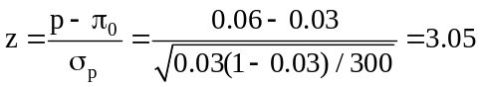
Critical value: z = 1.645
Decision rule: Reject H₀ if the calculated z > 1.645, otherwise do not reject.
Conclusion: Calculated test statistic falls in rejection region, reject H₀.
Decision: At the 0.05 level, this region should be considered as having a burglary problem greater than the nation as a whole, since the percentage of households burglarized in this region is significantly larger than 3.0%. Using the standard normal table, p-value = P(z > 3.05) =
1.0000 – 0.9989 = 0.0011. From the p-value perspective, we reject H₀ since p-value = 0.0011
is less than α = 0.05.
Using the Test Statistics workbook that accompanies Data Analysis Plus, the corresponding printout is shown below. For this right-tail test, the p-value is listed as 0.001.
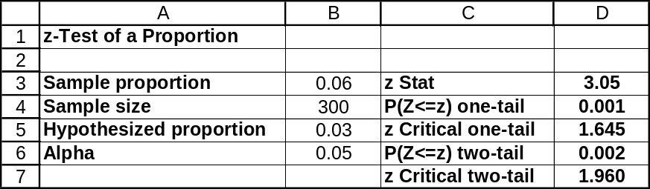

10.100 p/a/m Null and alternative hypotheses:
H₀: π ≤ 0.08 (no more Liberty families had refrigerators than the nation overall.)
H₁: π > 0.08 (more Liberty families had refrigerators than the nation overall.)
Level of significance: α = 0.01
Test results: p = 0.15, n = 120
Calculated value of test statistic: 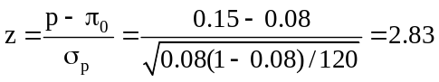
Critical value: z = 2.33
Decision rule: Reject H₀ if the calculated z > 2.33, otherwise do not reject.
Conclusion: Calculated test statistic falls in rejection region, reject H₀.
Decision: At the 0.01 level, the percentage of Liberty families owning a "mechanical refrigerator" was significantly higher than the nation overall.
Using the Test Statistics workbook that accompanies Data Analysis Plus, the corresponding printout is shown below. For this right-tail test, the p-value is listed as 0.002.
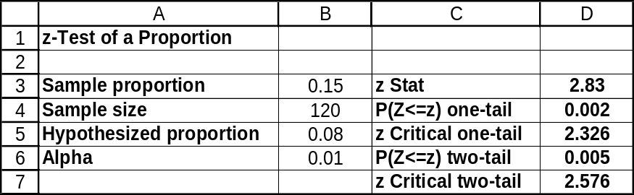

10.101 p/a/m Null and alternative hypotheses:
H₀: π = 0.30 (the administrator's statement is correct) and H₁: π ≠ 0.30 (statement is not correct)
Level of significance: α = 0.05
Test results: p = 0.35, n = 400
Calculated value of test statistic: 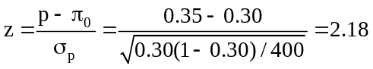
Critical values: z = -1.96 and z = 1.96
Decision rule: Reject H₀ if the calculated z < -1.96 or > 1.96, otherwise do not reject.
Conclusion: Calculated test statistic falls in rejection region, reject H₀.
Decision: At the 0.05 level, the administrator's statement does not appear to be correct. Based on these results, the true proportion of emergency room patients that are not really in need of emergency treatment is not 0.30.
Using the Test Statistics workbook that accompanies Data Analysis Plus, the corresponding printout is shown below. For this two-tail test, the p-value is listed as 0.029.
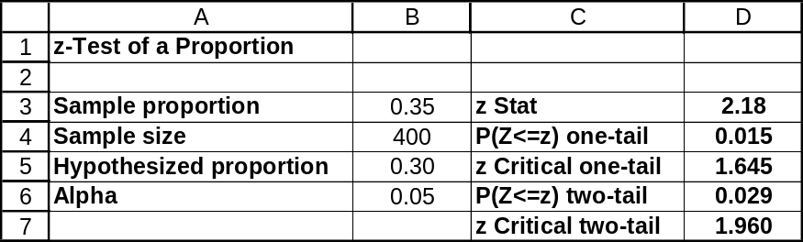

10.102 p/a/m Null and alternative hypotheses:
H₀: π ≤ 0.50 (no more than half prefer the chunky version)
H₁: π > 0.50 (more than half prefer the chunky version)
Level of significance: α = 0.05
Test results: p = 58/100 = 0.58, n = 100
Calculated value of test statistic: 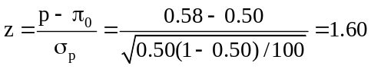
Critical value: z = 1.645
Decision rule: Reject H₀ if the calculated z > 1.645, otherwise do not reject.
Conclusion: Calculated test statistic falls in nonrejection region, do not reject H₀.
Decision: At the 0.05 level, we cannot conclude that this proportion is larger than the proportion
that would tend to result from chance. Using the standard normal table, p-value =
P(z > 1.60) = 1.0000 - 0.9452 = 0.0548. From the p-value perspective, we do not reject H₀ since p-value = 0.0548 is not less than α = 0.05.
Using the Test Statistics workbook that accompanies Data Analysis Plus, the corresponding printout is shown below. For this right-tail test, the p-value is listed as 0.055.
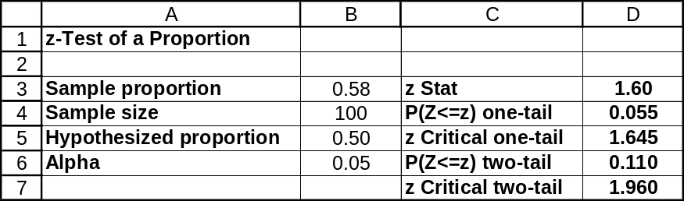

10.103 p/a/m Null and alternative hypotheses:
H₀: π ≤ 0.10 (exterminator's claim is correct) and H₁: π > 0.10 (claim is not correct)
Level of significance: α = 0.05
Test results: p = 14/100 = 0.14, n = 100
Calculated value of test statistic: 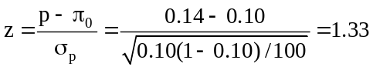
Critical value: z = 1.645
Decision rule: Reject H₀ if the calculated z > 1.645, otherwise do not reject.
Conclusion: Calculated test statistic falls in nonrejection region, do not reject H₀.
Decision: At the 0.05 level, we have no reason to doubt the exterminator's claim. The proportion of homes the exterminator treats that have termite problems within one year after treatment is not significantly larger than 0.10.
Using the Test Statistics workbook that accompanies Data Analysis Plus, the corresponding printout is shown below. For this right-tail test, the p-value is listed as 0.091.
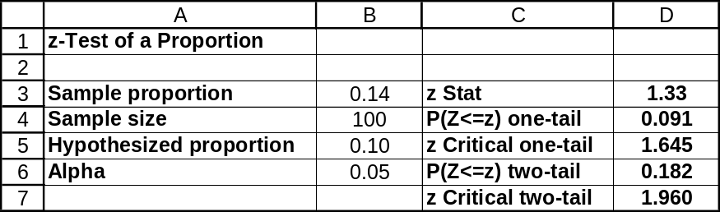

10.104 p/a/m Null and alternative hypotheses:
H₀: μ ≥ 5 (the chain's assertion is correct) and H₁: μ < 5 (assertion is not correct)
Level of significance: α = 0.01
Test results: = 4.6, s = 1.5, n = 40
Calculated value of test statistic: 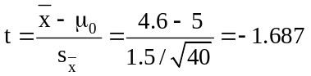
Critical value: t = -2.426 For this test, α = 0.01 and d.f. = (n - 1) = (40 - 1) = 39. Referring to the 0.01 column and the 39th row of the t table, the critical value is t = -2.426.
Decision rule: Reject H₀ if the calculated t < -2.426, otherwise do not reject.
Conclusion: Calculated test statistic falls in nonrejection region, do not reject H₀.
Decision: At the 0.01 level, the evidence is not strong enough to dismiss the health club's contention that the mean number of pounds lost by members during the past month was at least 5 pounds. The sample mean weight loss could have been this low merely by chance.
Using the Test Statistics workbook that accompanies Data Analysis Plus, the corresponding printout is shown below. For this left-tail test, the p-value is listed as 0.050.
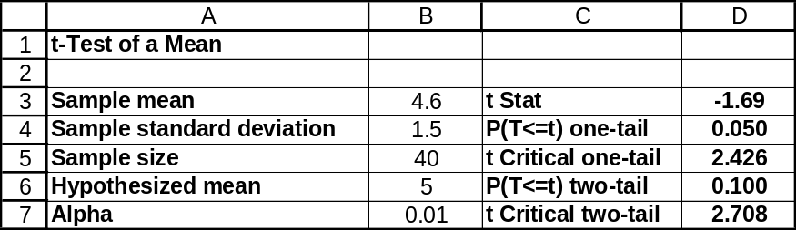

10.105 p/a/d Null and alternative hypotheses: H₀: π ≥ 0.75 and H₁: π < 0.75
The standard error of p can be calculated as: 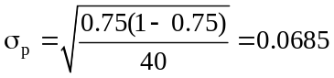
We must first express the decision rule "Reject H₀ if z < -1.645" in terms of p:
The sample proportion, p corresponding to z = -1.645 is p = 0.75 - 1.645(0.0685) = 0.637
The decision rule in terms of p will be: "Reject H₀ if p < 0.637."
a. Let π = 0.75:
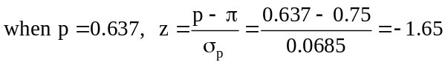
and β = P(z ≥ -1.65) = 1.0000 - 0.0495 = 0.9505
b. Let π = 0.70:
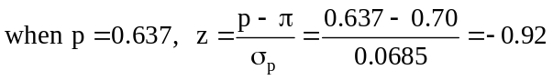
and β = P(z ≥ -0.92) = 1.0000 - 0.1788 = 0.8212
c. Let π = 0.65:
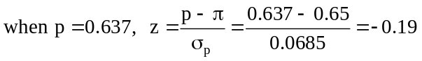
and β = P(z ≥ -0.19) = 1.0000 - 0.4247 = 0.5753
d. Let π = 0.60:
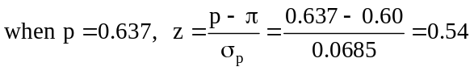
and β = P(z ≥ 0.54) = 1.0000 - 0.7054 = 0.2946
e. Let π = 0.55:
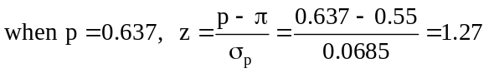
and β = P(z ≥ 1.27) = 1.0000 - 0.8980 = 0.1020

f. When π = 0.75, 1 - β = 1 - 0.9505 = 0.0495 When π = 0.70, 1 - β = 1 - 0.8212 = 0.1788
When π = 0.65, 1 - β = 1 - 0.5753 = 0.4247 When π = 0.60, 1 - β = 1 - 0.2946 = 0.7054
When π = 0.55, 1 - β = 1 - 0.1020 = 0.8980

Using Minitab, note that the “Alternative Proportion” column refers to the assumed actual π.
The Minitab results are much more accurate than the ones calculated above, largely due to our rounding in the quantities either leading to the calculation or resulting from it, including p, σ_{p}, and z.

Power and Sample Size
Test for One Proportion

Testing proportion = 0.75 (versus < 0.75)
Alpha = 0.05

Alternative Sample
Proportion Size Power
0.750000 40 0.0500
0.700000 40 0.1937
0.650000 40 0.4336
0.600000 40 0.6853
0.550000 40 0.8667

Using Excel to chart the power curve. This plot graphs the power of the test = 1 - β = probability that the hypothesis test will correctly reject a false null hypothesis against the assumed value of π.
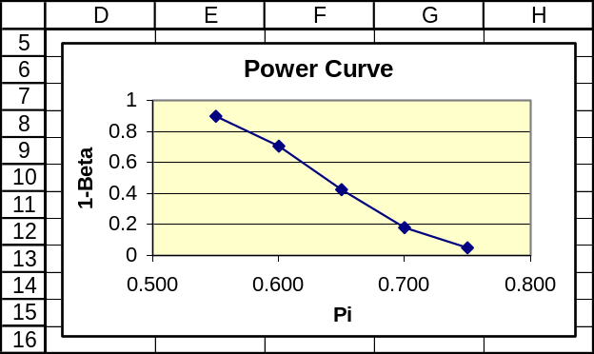

10.106 p/a/d
a. The null and alternative hypotheses are:
H₀: μ ≥ 1600 (the pet food company is not underfilling the packages)
H₁: μ < 1600 (the pet food company is underfilling the packages)
This test can be carried out with a pocket calculator and formulas, but we will use the Test Statistics workbook that accompanies Data Analysis Plus. As shown in the printout below,
the p-value for this left-tail test is 0.006. If the company were really putting an average of 1600 grams into the packages, there would be only a 0.006 probability of getting a sample mean this low.
Because p-value = 0.006 is less than α = 0.05, the consumer agency will reject H₀ and conclude that the company is underfilling the packages. Perhaps the president of the company might prefer to use an α value that is numerically very small, such as α = 0.00001, in order to force the conclusion that the null hypothesis would not be rejected.
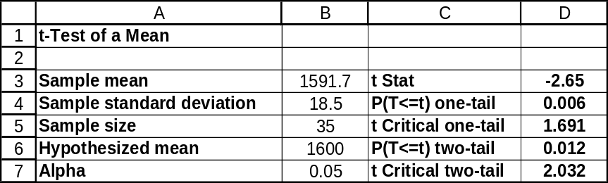

b. If we were relying on the pocket calculator and formulas, we would first have to express the decision rule for this test in terms of the sample mean: In a left-tail t-test at the 0.05 level, with n = 35, df will be (35 - 1) = 34 and the critical value of t will be t = -1.690. With s = 18.5 grams and n = 35, the standard error for the sample mean will be 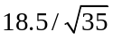= 3.127 grams.
The sample mean corresponding to the critical t = -1.690 will be 1600 -1.690(3.127), or 1595.7154 grams, and the decision rule will be "Reject H₀ if < 1595.7514 grams.”

We will bypass the pocket calculator and use Minitab to generate the power curve values for a range of assumed population means. These are: 1600, 1598, 1596, 1594, 1592, 1590, 1588, 1586, 1584, 1582, and 1580. The entries in the Difference column correspond to the difference between the assumed population mean and the value in the null hypothesis -- e.g., the -2.0000 entry corresponds to an assumed population mean of 1600 - 2.0000, or 1598.

Power and Sample Size
1-Sample t Test
Testing mean = null (versus < null)
Calculating power for mean = null + difference
Alpha = 0.05 Sigma = 18.5

Sample
Difference Size Power
0.0000 35 0.0500
-2.0000 35 0.1544
-4.0000 35 0.3478
-6.0000 35 0.5931
-8.0000 35 0.8057
-10.0000 35 0.9317
-12.0000 35 0.9828
-14.0000 35 0.9969
-16.0000 35 0.9996
-18.0000 35 1.0000
-20.0000 35 1.0000

Using Excel to chart the power curve.
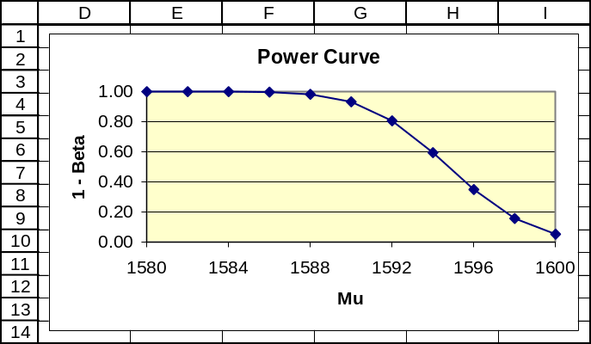

10.107 p/a/d
a. Shop-Mart should consider switching to Phipps bulbs. If the Phipps bulbs were really no better than the G&E, they would have had only a 0.012 probability of having this great an advantage in our tests just by chance.
b. G&E might like to use the 0.005 level of significance in reaching a conclusion. Since the p-value is not less than 0.005, using the α = 0.005 level would lead to the conclusion that the Phipps advantage in the test could have been merely due to chance.
c. Phipps might like to use the 0.02 level of significance in reaching a conclusion. Since the p-value is less than 0.02, using the α = 0.02 level would lead to the conclusion that the Phipps advantage in the test was not merely due to chance, and that the Phipps bulbs really are better.
d. If the test had been two-tail instead of one-tail, the p-value would have been 0.024. We would have had to consider two tail areas instead of just one, and the mirror-image area on the other side would also have been 0.012. In this case, the p-value would have been 2(0.012) = 0.024.

10.108 p/c/m The null and alternative hypotheses are H₀: μ ≤ $2.75 and H₁: μ > $2.75.
Printout results are shown below for Data Analysis Plus and Minitab. In this right-tail test, the sample mean of $3.30 exceeds the hypothesized mean of $2.75 and the p-value is 0.001.
Since the p-value is less than the level of significance being used to reach a conclusion (0.025), we reject the null hypothesis and conclude that the new exhibit has increased the average contribution of exhibit patrons. If the new exhibit were no better than the old exhibit in attracting contributions, there would be only a 0.001 probability of obtaining a sample mean this large.
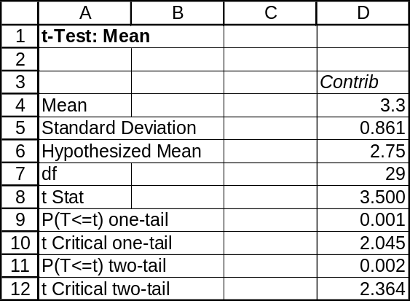

One-Sample T: Contrib
Test of mu = 2.75 vs mu > 2.75

Variable N Mean StDev SE Mean
Contrib 30 3.300 0.861 0.157

Variable 95.0% Lower Bound T P
Contrib 3.033 3.50 0.001

10.109 p/c/m The null and alternative hypotheses are H₀: π = 0.25 and H₁: π ≠ 0.25.
Printout results are shown below for Data Analysis Plus. Of the 400 crimes in the sample, 30.25% involved a weapon. In this two-tail test, the p-value is 0.015, which is less than the 0.05 level of significance being used to reach a conclusion. We reject the null hypothesis and conclude that this city’s experience is different from the nation as a whole in terms of the percent of violent crimes that involve a weapon. If the city were really the same as the rest of the nation, there would be only a 0.015 probability of obtaining a sample proportion this far away from 0.25.
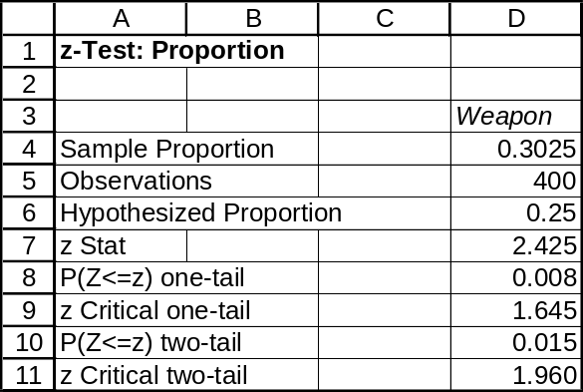

10.110 p/c/m The Data Analysis Plus printout below shows the 95% confidence interval for π as
0.2575 to 0.3475. Since the hypothesized value (0.25) is outside the interval, we conclude that this city’s proportion must be some value other than 0.25. This is the same conclusion that was reached in exercise 10.109.
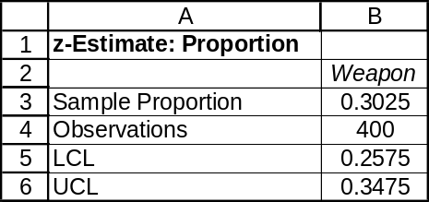

10.111 p/c/m The null and alternative hypotheses are H₀: μ ≥ 3.5 and H₁: μ < 3.5.
Printout results are shown for Data Analysis Plus and Minitab. In this left-tail test, the sample mean of 3.293 ounces is less than the hypothesized mean (3.5000), but the p-value (0.059) is not less than the level of significance used to reach a conclusion (0.01), so we do not reject the null hypothesis. The new procedure has not significantly reduced the average amount of aluminum trimmed and recycled. At this level of significance, a sample mean this small could have happened by chance.
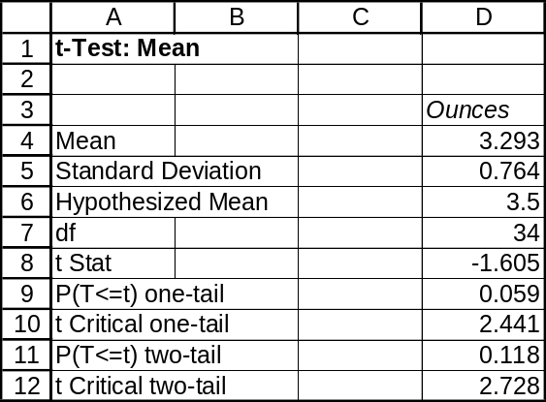

One-Sample T: Ounces
Test of mu = 3.5 vs mu < 3.5

Variable N Mean StDev SE Mean
Ounces 35 3.293 0.764 0.129

Variable 95.0% Upper Bound T P
Ounces 3.511 -1.61 0.059

10.112 p/c/m Using Minitab to determine the power of the test for a selection of assumed values for the actual population mean, we obtain the results shown below. The selected assumed values range from 3.5 ounces (Difference = 0) to 2.5 ounces (Difference = -1.0).

Power and Sample Size
1-Sample t Test

Testing mean = null (versus < null)
Calculating power for mean = null + difference
Alpha = 0.01 Sigma = 0.764

Sample
Difference Size Power
0.0 35 0.0100
-0.1 35 0.0568
-0.2 35 0.2008
-0.3 35 0.4619
-0.4 35 0.7411
-0.5 35 0.9176
-0.6 35 0.9834
-0.7 35 0.9980
-0.8 35 0.9998
-0.9 35 1.0000
-1.0 35 1.0000

Using Excel to chart the power curve.
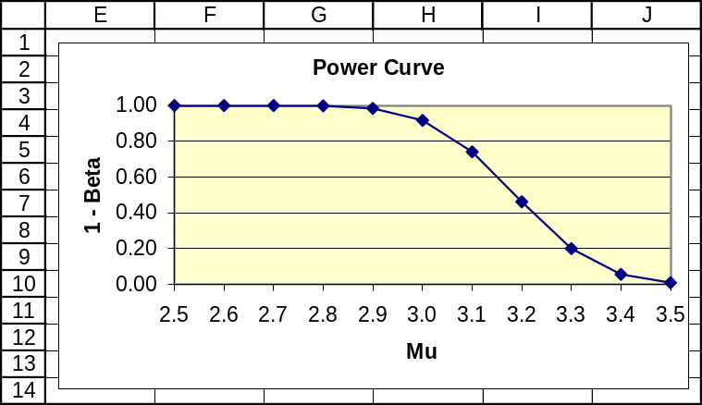

10.113 p/c/m The null and alternative hypotheses are H₀: μ ≤ 12,000 hours and H₁: μ > 12,000 hours
Printout results are shown below for Data Analysis Plus and Minitab. In this right-tail test, the sample mean of 12,070.38 hours exceeds the hypothesized mean (12,000) and the p-value is 0.282.
Since the p-value is not less than the level of significance specified (0.025), we do not reject the null hypothesis. The new injection pumps may be no better than the ones already in use.
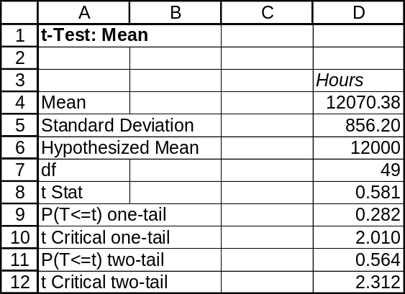

One-Sample T: Hours
Test of mu = 12000 vs mu > 12000

Variable N Mean StDev SE Mean
Hours 50 12070 856 121

Variable 95.0% Lower Bound T P
Hours 11867 0.58 0.282

INTEGRATED CASES

THORNDIKE SPORTS EQUIPMENT

For 40 racquetball racquets, the null and alternative hypotheses are:
H₀: μ ≥ 3.25 (the Cromwell machine is not faster) and H₁: μ < 3.25 (Cromwell machine is faster)
Using Minitab, we obtain the following results:

One-Sample T: RBRacq
Test of mu = 3.25 vs mu < 3.25

Variable N Mean StDev SE Mean
RBRacq 40 3.1507 0.2443 0.0386

Variable 95.0% Upper Bound T P
RBRacq 3.2158 -2.57 0.007

The p-value for this test is 0.007. If the population mean were exactly μ = 3.25, the probability of obtaining a sample mean this small or smaller would be just 0.007. If the p-value of 0.007 is less than the level of significance being used to reach a conclusion, we will reject the null hypothesis. This p-value is very small, and it seems safe to conclude that the Cromwell machine is faster than the current models at stringing racquetball racquets.

For 40 tennis racquets, the null and alternative hypotheses are:
H₀: μ ≥ 4.13 (the Cromwell machine is not faster) and H₁: μ < 4.13 (Cromwell machine is faster)
Using Minitab, we obtain the following results:

One-Sample T: TennRacq
Test of mu = 4.13 vs mu < 4.13

Variable N Mean StDev SE Mean
TennRacq 40 4.0110 0.3377 0.0534

Variable 95.0% Upper Bound T P
TennRacq 4.1010 -2.23 0.016

The p-value for this test is 0.016. If the population mean were exactly μ = 4.13, the probability of obtaining a sample mean this small or smaller would be just 0.016. If the p-value of 0.016 is less than the level of significance being used to reach a conclusion, we will reject the null hypothesis. This p-value is very small, and it seems safe to conclude that the Cromwell machine is faster than the current models at stringing tennis racquets.

From the results obtained above, Ted can be very confident that the Cromwell machine is faster than the current models at stringing both racquetball and tennis racquets. The tests appear to warrant purchase of the Cromwell machine.

SPRINGDALE SHOPPING SURVEY

1a. through 1d.
All of the desired information for Springdale Mall is provided within the t-test printout below:

One-Sample T: SPRILIKE
Test of mu = 3 vs mu not = 3
Variable N Mean StDev SE Mean
SPRILIKE 150 4.0867 0.7766 0.0634

Variable 90.0% CI T P
SPRILIKE ( 3.9817, 4.1916) 17.14 0.000

- Yes, this area seems well regarded by the respondents. Recall that numerically higher scores are better.
- In testing H₀: μ₇ = 3.0 versus H₁: μ₇ 3.0, the p-value (0.000, rounded to three decimal places) is less than 0.10, the level of significance specified for the test. We reject the null hypothesis that the population mean is equal to 3.0.
- The 90% confidence interval for μ₇ is shown in the printout. The hypothesized value (3.0) falls outside the 90% confidence interval. This is consistent with the hypothesis test result using the 0.10 level of significance.
- As shown above, the p-value for the hypothesis test is 0.000 (to three decimal places).

1e. All of the desired information for Downtown is provided within the t-test printout below:

One-Sample T: DOWNLIKE
Test of mu = 3 vs mu not = 3
Variable N Mean StDev SE Mean
DOWNLIKE 150 3.5200 0.9392 0.0767

Variable 90.0% CI T P
DOWNLIKE ( 3.3931, 3.6469) 6.78 0.000

- Yes, this area seems well regarded by the respondents, but less so than Springdale Mall. Recall that numerically higher scores are better.
- In testing H₀: μ₈ = 3.0 versus H₁: μ₈ 3.0, the p-value (0.000, rounded to three decimal places) is less than 0.10, the level of significance specified for the test. We reject the null hypothesis that the population mean is equal to 3.0.
- The 90% confidence interval for μ₈ is shown in the printout. The hypothesized value (3.0) falls outside the 90% confidence interval. This is consistent with the hypothesis test result using the 0.10 level of significance.
- As shown above, the p-value for the hypothesis test is 0.000 (to three decimal places).

1f. All of the desired information for West Mall is provided within the t-test printout below:

One-Sample T: WESTLIKE
Test of mu = 3 vs mu not = 3
Variable N Mean StDev SE Mean
WESTLIKE 150 3.2467 1.0423 0.0851

Variable 90.0% CI T P
WESTLIKE ( 3.1058, 3.3875) 2.90 0.004

- Yes, this area seems well regarded by the respondents, but less so than Springdale Mall and Downtown. Recall that numerically higher scores are better.
- In testing H₀: μ₉ = 3.0 versus H₁: μ₉ 3.0, the p-value (0.004) is less than 0.10, the level of significance specified for the test. We reject the null hypothesis that the population mean is equal to 3.0.
- The 90% confidence interval for μ₉ is shown in the printout. The hypothesized value (3.0) falls outside the 90% confidence interval. This is consistent with the hypothesis test result using the 0.10 level of significance.
- As shown above, the p-value for the hypothesis test is 0.004.

2. Shown below are the Minitab counts for variables 10 through 17:

BSTEXCHG Count BSTQUALI Count BSTPRICE Count BSTVARIE Count
1 72 1 93 1 22 1 123
2 23 2 43 2 16 2 18
3 21 3 6 3 99 3 5
4 34 4 8 4 13 4 4
N= 150 N= 150 N= 150 N= 150

BSTHELP Count BSTHOURS Count BSTCLEAN Count BSTBARGN Count
1 64 1 109 1 120 1 48
2 42 2 9 2 10 2 33
3 10 3 19 3 10 3 55
4 34 4 13 4 10 4 14
N= 150 N= 150 N= 150 N= 150

2a. through 2c. Tests for Springdale Mall, variables 10 through 17:

BSTEXCHG
Test of p = 0.333 vs p not = 0.333
Sample X N Sample p 95.0% CI Z-Value P-Value
1 72 116 0.620690 (0.532391, 0.708988) 6.57 0.000

BESTQUALI
Test of p = 0.333 vs p not = 0.333
Sample X N Sample p 95.0% CI Z-Value P-Value
1 93 142 0.654930 (0.576739, 0.733120) 8.14 0.000

BSTPRICE
Test of p = 0.333 vs p not = 0.333
Sample X N Sample p 95.0% CI Z-Value P-Value
1 22 137 0.160584 (0.099105, 0.222063) -4.28 0.000

BSTVARIE
Test of p = 0.333 vs p not = 0.333
Sample X N Sample p 95.0% CI Z-Value P-Value
1 123 146 0.842466 (0.783373, 0.901559) 13.06 0.000

BSTHELP
Test of p = 0.333 vs p not = 0.333
Sample X N Sample p 95.0% CI Z-Value P-Value
1 64 116 0.551724 (0.461223, 0.642225) 5.00 0.000

BSTHOURS
Test of p = 0.333 vs p not = 0.333
Sample X N Sample p 95.0% CI Z-Value P-Value
1 109 137 0.795620 (0.728096, 0.863145) 11.49 0.000

BSTCLEAN
Test of p = 0.333 vs p not = 0.333
Sample X N Sample p 95.0% CI Z-Value P-Value
1 120 140 0.857143 (0.799178, 0.915107) 13.16 0.000

BSTBARGN
Test of p = 0.333 vs p not = 0.333
Sample X N Sample p 95.0% CI Z-Value P-Value
1 48 136 0.352941 (0.272625, 0.433257) 0.49 0.622

These tests can be summarized as shown below. Note that n refers to the number of persons who selected one of the three shopping areas and p = the proportion of those persons who expressed a choice who selected Springdale Mall as the “best” location associated with that variable.
The rightmost column shows the p-value for the test of H₀:  = 0.333, whether the population proportion selecting Springdale Mall could be 0.333.
variable number | variable name | n | p | z | p-value
10 | BSTEXCHG | 116 | 0.621 | 6.57 | 0.000
11 | BSTQUALI | 142 | 0.655 | 8.14 | 0.000
12 | BSTPRICE | 137 | 0.161 | -4.28 | 0.000
13 | BSTVARIE | 146 | 0.842 | 13.06 | 0.000
14 | BSTHELP | 116 | 0.552 | 5.00 | 0.000
15 | BSTHOURS | 137 | 0.796 | 11.49 | 0.000
16 | BSTCLEAN | 140 | 0.857 | 13.16 | 0.000
17 | BSTBARGN | 136 | 0.353 | 0.49 | 0.622
Of variables 10 through 17, and using the α = 0.05 level of significance, we would reject
H₀: π = 0.333 for all except one: variable 17 (BSTBARGN).

2d. Springdale Mall is the strongest of the three areas in all but two of these eight attributes.
The only attributes for which it is not the "best-fit" are best prices and bargain sales.

BUSINESS CASE

PRONTO PIZZA (A)

We must first create a new variable called Tot_Time, which represents the total amount of time from the call being received to the delivery being made. It will be the total of Prep_Time, Wait_Time, and Travel_Time, and it is the time to which the guarantee would be applied.

1. In examining whether the population average for Tot_Time might be greater than 25 minutes, our null and alternative hypotheses are H₀: μ ≤ 25 and H₁: μ > 25. We will use α = 0.05 as the level of significance for this right-tail test. The Minitab printout is shown below.
Because p-value = 0.104 is not less than the 0.05 level of significance for the test, we fail to reject H₀ and we conclude that the mean delivery time could be no more than 25 minutes.

One-Sample T: Tot_Time
Test of mu = 25 vs > 25
95%
Lower
Variable N Mean StDev SE Mean Bound T P
Tot_Time 240 25.3205 3.9249 0.2534 24.9021 1.26 0.104

2. One approach is to sort the existing data in order of size and manually determine the percentage of cases in which Tot_Time was 29 minutes or less. This arrangement is shown below. An alternative is to use a Minitab histogram with the cutpoints set at 9.001, 29.001, and 49.001. The first bar in the histogram will include values that are at least 9.001, but less than 29.001, so this bar will include all the cases for which Tot_Time was 29.00 minutes or less. As we see in the histogram, Tot_Time was 29.00 minutes or less in 207 out of the 240 deliveries. This is a “success” percentage of 86.25%, but this means that Pronto failed to meet the 29.00-minute deadline in 13.75% of its deliveries. On this basis, it does not appear that Pronto will meet its requirement of failing to meet the guarantee no more than 5% of the time.

Data Display

Tot_Time

16.90 17.87 18.53 19.20 19.39 19.49 19.90 19.97 20.03
20.13 20.32 20.41 20.41 20.53 20.69 20.78 20.79 20.80
20.87 20.90 20.98 21.03 21.05 21.07 21.21 21.27 21.38
21.53 21.54 21.68 21.70 21.73 21.73 21.79 21.81 21.83
21.89 21.91 21.99 22.03 22.07 22.11 22.18 22.20 22.24
22.25 22.29 22.32 22.33 22.35 22.41 22.45 22.47 22.71
22.77 22.79 22.79 22.84 22.85 22.85 22.86 22.87 22.89
22.91 22.91 23.00 23.04 23.04 23.08 23.16 23.18 23.22
23.26 23.27 23.28 23.31 23.32 23.39 23.43 23.44 23.45
23.47 23.52 23.53 23.58 23.61 23.62 23.64 23.72 23.78
23.79 23.80 23.80 23.90 23.96 23.97 24.00 24.01 24.03
24.07 24.15 24.19 24.20 24.25 24.30 24.33 24.39 24.40
24.41 24.41 24.42 24.43 24.45 24.48 24.50 24.50 24.52
24.66 24.67 24.69 24.71 24.73 24.76 24.76 24.82 24.83
24.83 24.84 24.88 24.88 24.89 24.91 24.97 25.01 25.12
25.14 25.26 25.33 25.35 25.38 25.44 25.45 25.46 25.48
25.56 25.61 25.62 25.65 25.67 25.69 25.71 25.72 25.75
25.76 25.79 25.81 25.85 25.86 25.87 25.92 25.98 25.98
26.00 26.06 26.16 26.25 26.32 26.40 26.42 26.48 26.49
26.51 26.52 26.53 26.61 26.64 26.74 26.75 26.77 26.78
26.79 26.87 26.89 26.95 26.96 27.24 27.27 27.40 27.43
27.46 27.47 27.48 27.49 27.71 27.87 27.91 27.97 28.12
28.25 28.44 28.56 28.59 28.66 28.78 28.79 28.86 28.87
29.06 29.36 29.43 29.50 29.65 29.67 29.74 29.97 29.97
30.20 30.31 30.63 30.69 30.79 30.89 31.76 31.90 31.95
32.42 32.55 32.88 33.02 33.05 33.58 34.04 34.12 34.31
34.72 36.48 37.30 39.42 40.22 46.00

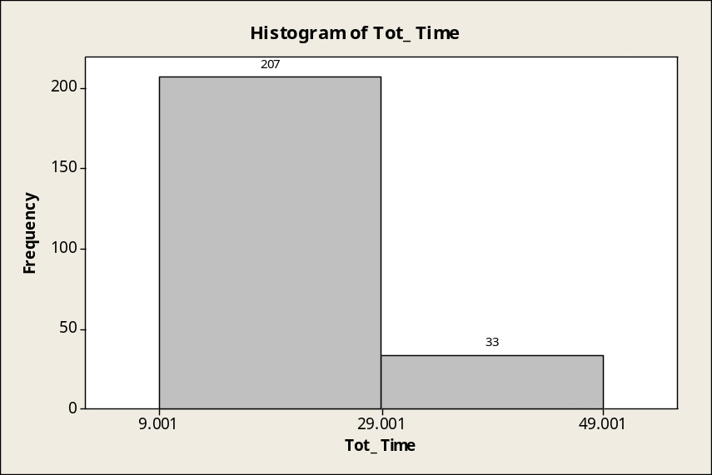

3. Comparing the average delivery times for different days of the week, Monday (code 3) has the shortest mean delivery time (23.886 minutes) and Saturday (code 6) has the longest mean delivery time (27.816 minutes). It appears that the day of the week does have an effect on the average time a customer will have to wait for his or her pizza. Of particular note is the relatively high standard deviation for the Saturday delivery times and the fact that the third quartile for this day is 29.665 minutes. On Saturdays, 25% of the deliveries require at least 29.665 minutes, a time that itself exceeds the desired guaranteed delivery time of 29 minutes. Friday delivery times also have a relatively high mean and standard deviation. In addition, the Friday third quartile value of 28.473 minutes is very high, nearly as great as the 29 minutes for the planned guarantee.

Descriptive Statistics: Tot_Time
Variable Day N Mean SE Mean StDev Minimum Q1 Median Q3
Tot_Time 1 32 23.886 0.600 3.397 17.870 22.068 23.105 26.135
2 32 25.054 0.553 3.126 20.530 23.143 24.500 25.793
3 32 24.453 0.452 2.557 16.900 22.857 24.425 25.708
4 32 23.928 0.399 2.255 20.030 22.335 23.895 25.573
5 40 26.541 0.595 3.764 19.390 23.705 26.360 28.473
6 40 27.816 0.894 5.653 20.410 24.185 26.245 29.665
7 32 24.637 0.622 3.519 19.490 21.870 24.415 26.393

Variable Day Maximum
Tot_Time 1 32.880
2 34.040
3 29.970
4 28.790
5 34.310
6 46.000
7 33.050

4. As shown in the printout below, the longest delivery times are associated with the 5:00-5:59 hour (mean time = 26.545 minutes) and the shortest tend to be associated with the 11:00-11:59 hour (mean time = 24.703 minutes). The third quartile for the 5:00-5:59 hour is 29.378 minutes, which exceeds the 29-minute planned guarantee, as does the third quartile for the 7:00-7:59 hour (29.688 minutes). For orders placed during each of these hours, at least 25% of the deliveries will take longer than the planned guarantee.

Descriptive Statistics: Tot_Time
Variable Hour N Mean SE Mean StDev Minimum Q1 Median Q3
Tot_Time 4 30 24.926 0.712 3.898 18.530 22.790 23.990 25.805
5 30 26.545 0.714 3.910 20.410 22.900 26.070 29.378
6 30 25.760 0.643 3.523 20.030 23.180 25.500 27.523
7 30 25.851 0.761 4.168 19.200 23.155 25.660 29.688
8 30 24.777 0.831 4.549 20.790 22.313 23.700 25.830
9 30 25.169 0.823 4.507 16.900 22.645 24.465 26.550
10 30 24.833 0.515 2.818 19.900 22.883 24.695 25.765
11 30 24.703 0.697 3.818 17.870 22.440 23.920 27.310

Variable Hour Maximum
Tot_Time 4 39.420
5 34.720
6 34.310
7 34.040
8 46.000
9 40.220
10 31.900
11 36.480

5. Based on the preceding analyses, Pronto Pizza may wish to increase its guaranteed time to a value slightly higher than 29 minutes. Another possibility, albeit one that could cause confusion among customers, is to guarantee 29-minute delivery only during days and/or times other than those cited previously. Because Tony will not be able to meet his 29-minute guarantee 95% of the time, as desired, he may wish to either increase the time specified in the guarantee or offer something less expensive than a free pizza if the guarantee is not met -- perhaps a free side order of bread sticks or a discount coupon for customers who have to wait longer than 29 minutes.

